
- ITP 2023





REPORT
ITP 2023: A research training programme on Machine Learning for climate change mitigation in buildings

Project chairman: Prof. Madg Abdel Wahab
Team members: LE Quang Huy
HOANG Quynh Anh
Place: University of Gent (Belgium),
Period: 3/5/2023 - 30/6/2023

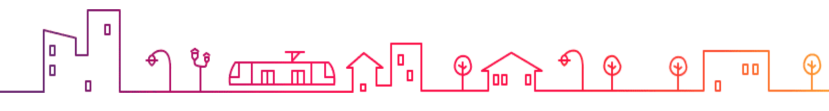
Table of Contents
PART 1. GENERAL INFORMATION ABOUT THE BUILDING 4
I. LOCATION 4
II. CLIMATE 4
III. BUILDING DESIGN 5
PART 2. STEP-BY STEP PROCEDURE TO BUILD AN ENERGY MODEL IN TERMUS-PLUS RESIDENTIAL BUIDING IN AN GIANG PROVINCE, VIETNAM 7
I. GEOMETRY FORMATION 7
I.1. Create 2D grid for plan 7
I.2. Define elevating references 7
I.3. Define BIM objects for energy calculations 8
a. Material layers 8
b. Glasses and frames for doors and windows 9
c. Doors and Windows 9
I.4. Construct elements for energy modeling 9
a. Vertical envelopes 10
b. Horizontal envelopes 11
c. Roof 13
d. Doors & windows 14
e. Holes 15
f. Completed model 15
II. DETECT, CALCULATE AND ASSIGN THERMAL BRIDGE OBJECTS 16
III. BOUNDARY CONDITIONS AND THERMAL DATA 19
III.1. Location and climate data 19
III.2. BEM and Zone for the building 21
III.3. Thermal power station 21
IV. DEFINE AND ASSIGN FUNCTIONAL ZONES TO THE BUILDING 22
V. ANALYZE DIAGNOSTICS AND START SIMULATION 23
VI. EXTRACT RESULTS 24
VII. THEORY ABOUT THERMAL BRIDGE 26
VII.1. Energy used by households 26
VII.2. Essential concepts 27
VII.3. Thermal bridge (cold bridge) 28
a. Defiition of Thermal bridge (cold bridge) 28
b. Types of thermal bridge (cold bridge) 29
c. Energy loss because of thermal bridge (cold bridge) 30
d. Thermal bridge (cold bridge) calculation 30
VII.4. Determining the thermal transmittance 30
VII.5. Boundary conditions/ transfer resistances 31
VII.6. Determining the minimum surface temperature and the f factor 32
VII.7. Boundary conditions for temperatures 32
VII.8. Example of a thermal bridge calculation 33
VIII. DESIGNED VARIABLES FOR MACHINE LEARNING MODEL 34
VIII.1. Object library for case-to-case simulations 34
VIII.2. Randomly creating scenarios and case-to-case simulating 35
VIII.3. Numerical data for ML model 36
a.. Input variables 36
b. Output 36
IX. NEURAL NETWORKS MODEL FOR ENERGY PREDICTIONS 37
IX.1. Neural network development 37
IX.2. Relative importance analysis 40
a. Connection Weights method (2002) (proposed by Julian D. Olden, Donald A. Jackson [1]) 40
b. Variable Perturbation method 42
X. OPTIMIZATION FOR ENERGY PROBLEM 43
X.1. Problem statement 43
X.2. Solution 45
XI. CONCLUSION AND FUTURE RESEARCH DIRECTION 48
XI.1. Conclusions 48
XI.2. Achievements from the training program 48
XI.3. Recommendations for follow-up research study 49

PART 1. GENERAL INFORMATION ABOUT THE BUILDING
---

LOCATION
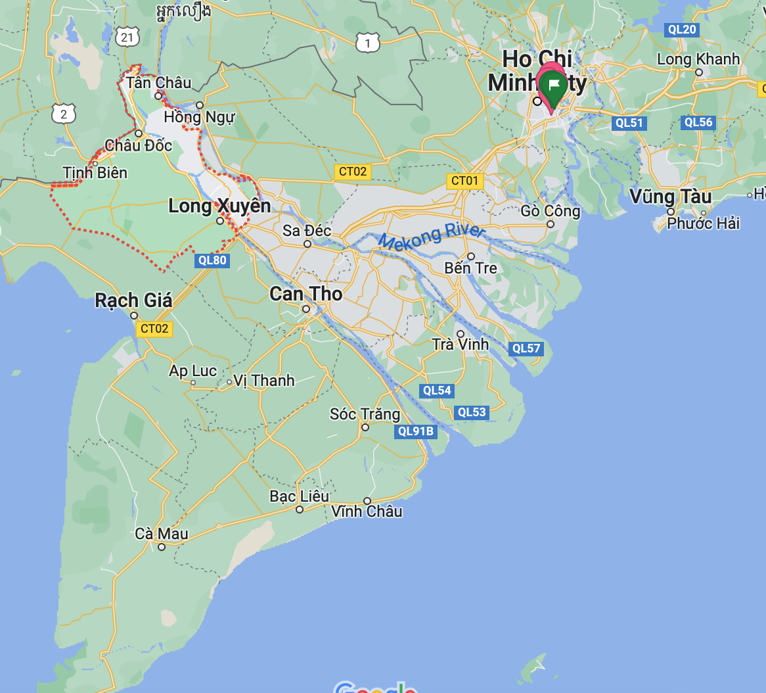
An Giang province
The building is located in An Giang province that is in southern Vietnam, bordering Cambodia. The province lies in the Mekong Delta and tributaries of the vast Mekong River run through its fertile landscape.

CLIMATE
With the geographical location in the Mekong Delta, An Giang's climate is in the tropical monsoon climate area. It is divided into two distinct seasons with the rainy season lasting from May to November and the dry season lasting from December to April next year.
The climate is affected by two main wind seasons: the southwest monsoon, which brings cool and moist air, and the northeast monsoon, which blows from the tropical sea from China, making the air dry. and hot.
The average temperature in An Giang ranges from 26ºC to 28ºC. The highest temperature is 35ºC - 36ºC in April and May. The lowest temperature is 20ºC -21ºC in December and January.

BUILDING DESIGN
- Address: An Giang province
- Architectural type: townhouse style, simple design with light colors, sloping roof
- Floors: ground floor and first floor. The ground floor is 56m², designed with the function spaces: garage, living room, kitchen, dining room, toilet, maid room, stair, terraces, and gardens. The first floor has an area of 57m², including 3 bedrooms, one working area, 2 toilets, laundry and drying spaces, and a void. Total area is 113m².
- The house serves for the purpose of family living.

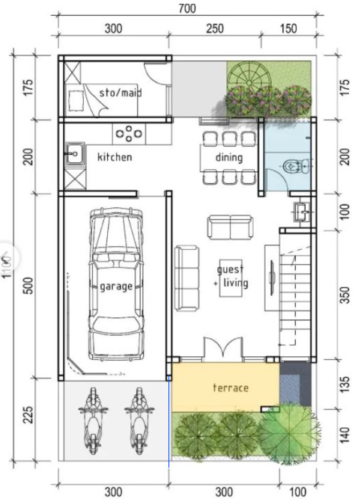  Ground floor | 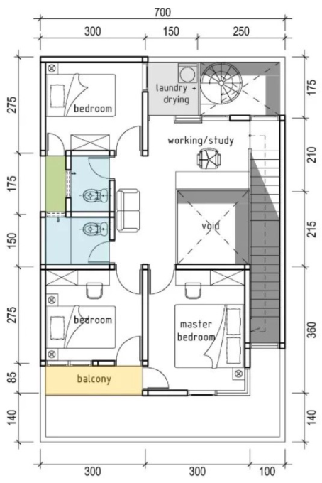  First floor

  Front view | 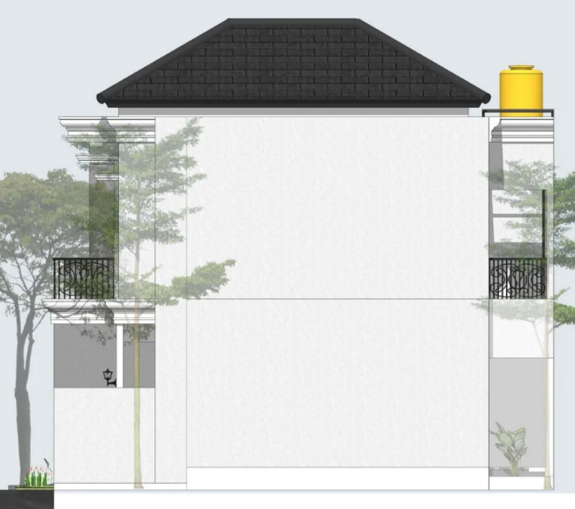  Side view

  General view | 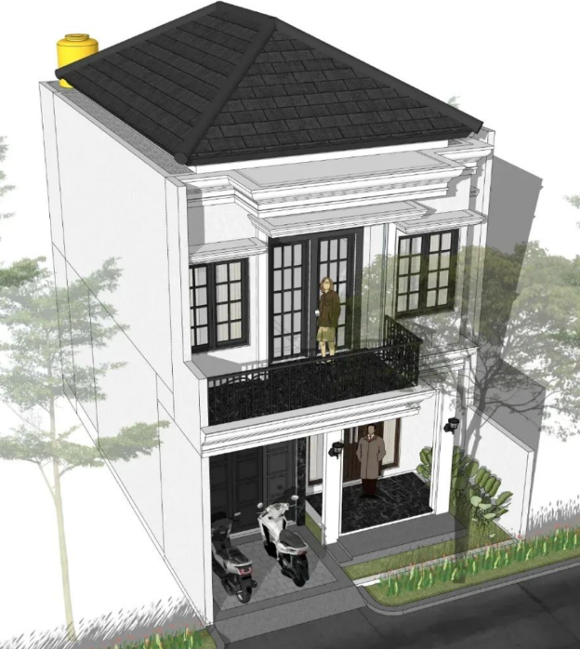  General view

PART 2. STEP-BY STEP PROCEDURE TO BUILD AN ENERGY MODEL IN TERMUS-PLUS RESIDENTIAL BUIDING IN AN GIANG PROVINCE, VIETNAM
---

GEOMETRY FORMATION

I.1. Create 2D grid for plan
 |  | 

I.2. Define elevating references
 | 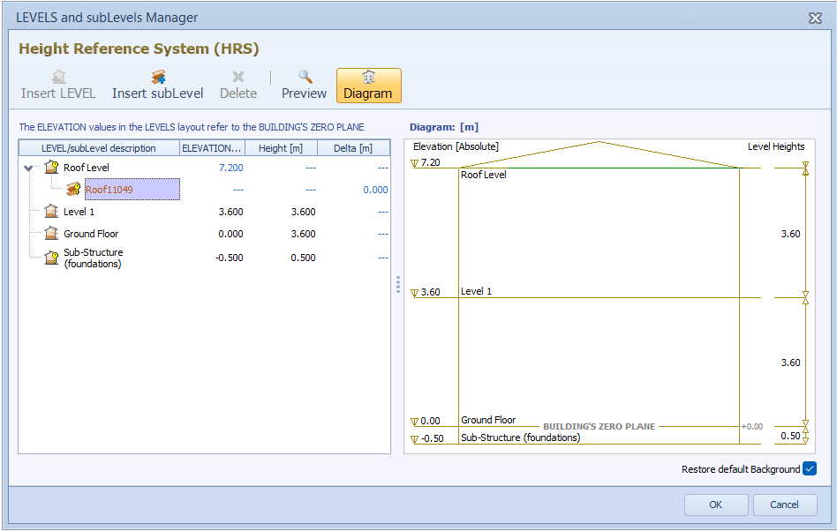

I.3. Define BIM objects for energy calculations

Material layers
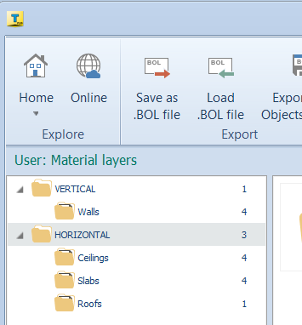
The material layers libraries are created for Vertical entities including walls, and for Horizontal entities including ceiling, slabs, and roof.
The BIM object library is created to be suitable for constructions built in Vietnam.

The solid brick walls are created with cement covering external and internal faces of the walls.
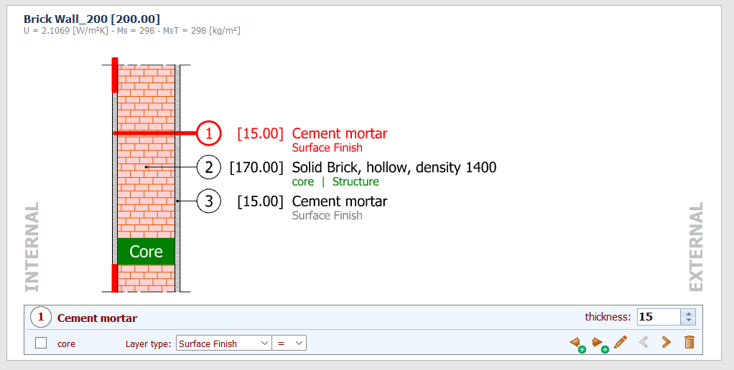
The concrete slab and ceiling are created with components commonly constructed in Vietnam
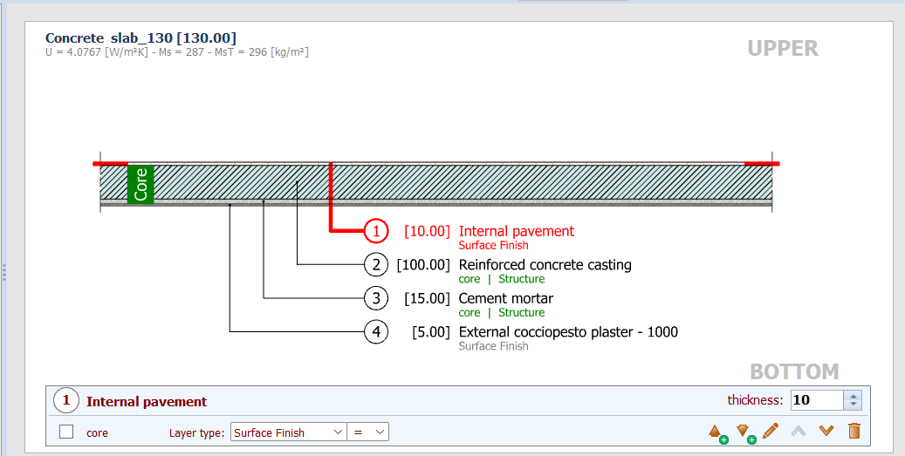
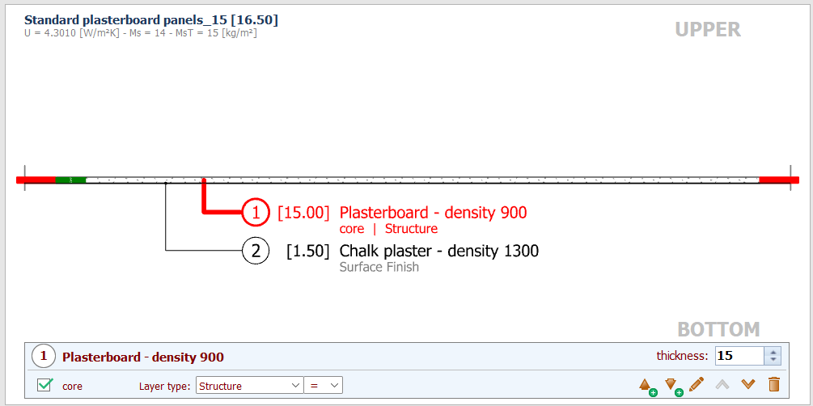

Glasses and frames for doors and windows
Glasses and frames are defined and assigned thermal properties. Afterward, they are assigned to door and window elements because they are part of the door and window elements.
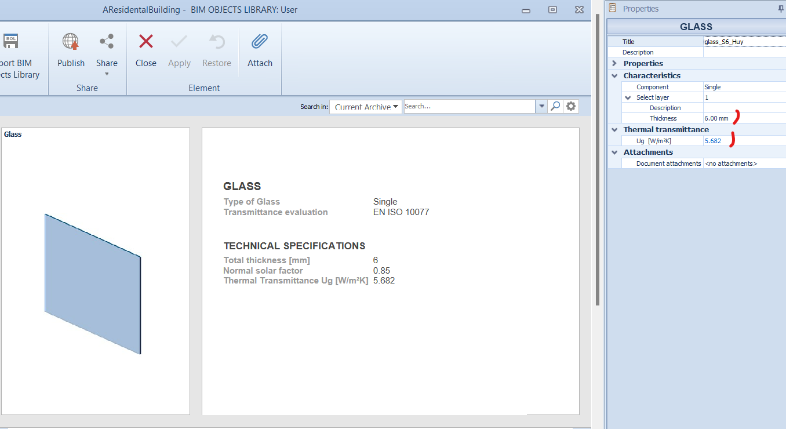 | 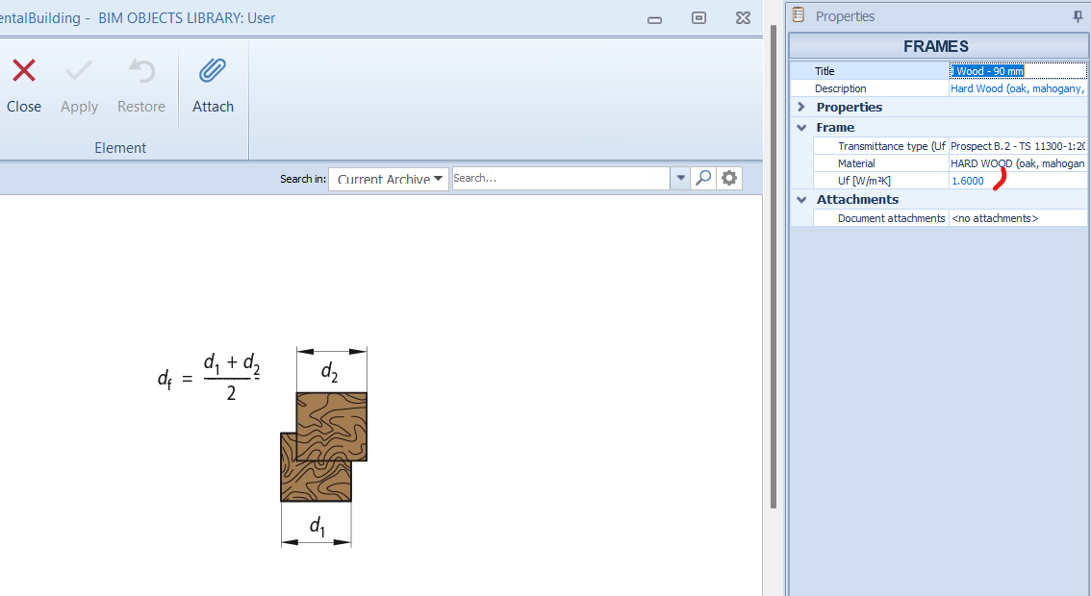

Doors and Windows
Door and window objects are created by linking the frame and glass components to their configuration and by assigning thermal data and geometric measurements.
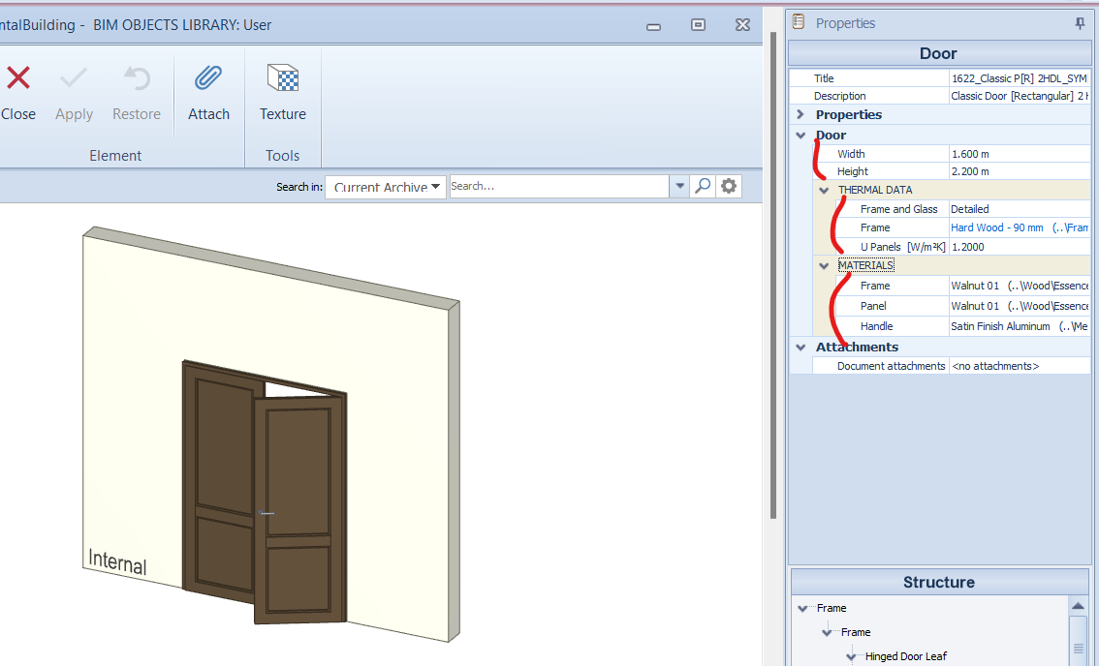 | 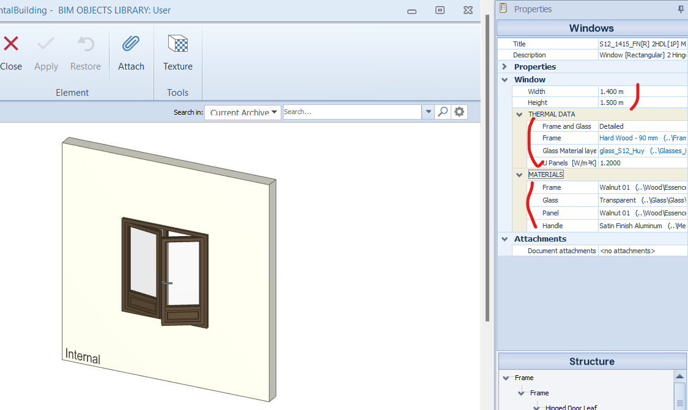

I.4. Construct elements for energy modeling
After library for BIM objects are created, envelopes and elements constructing the building are drawn with corresponding objects in the library.

Vertical envelopes
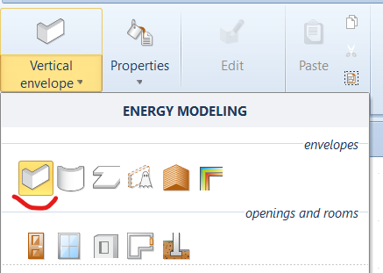 | 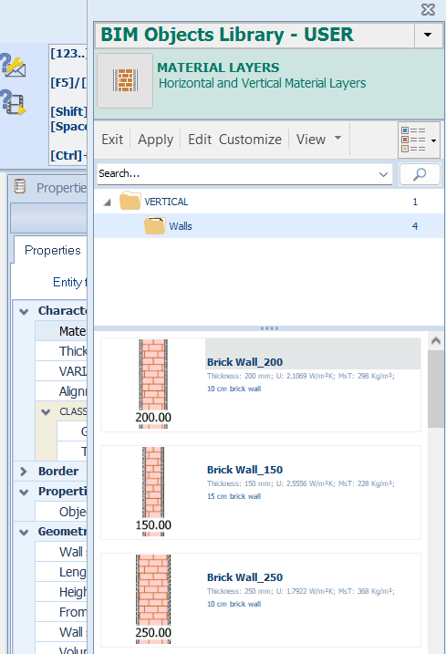

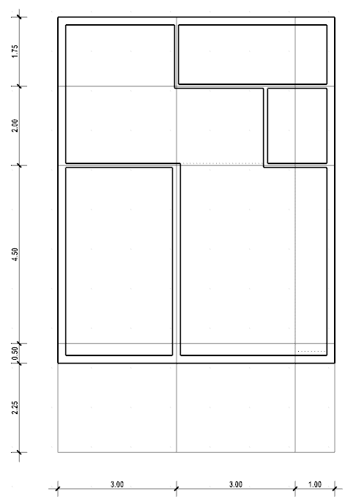 | 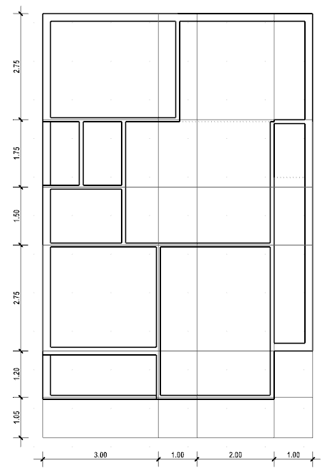

Horizontal envelopes
 | 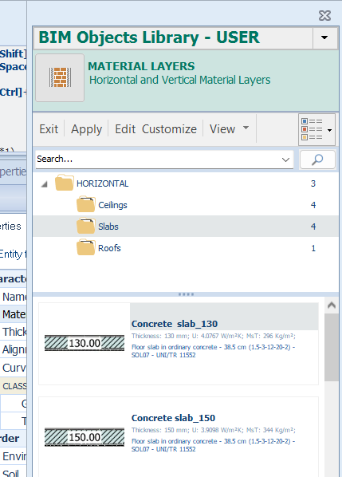

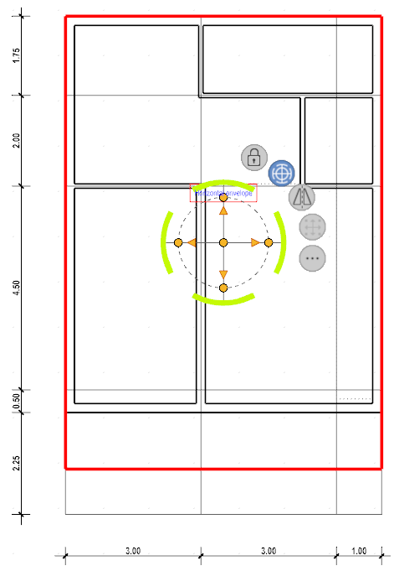 | 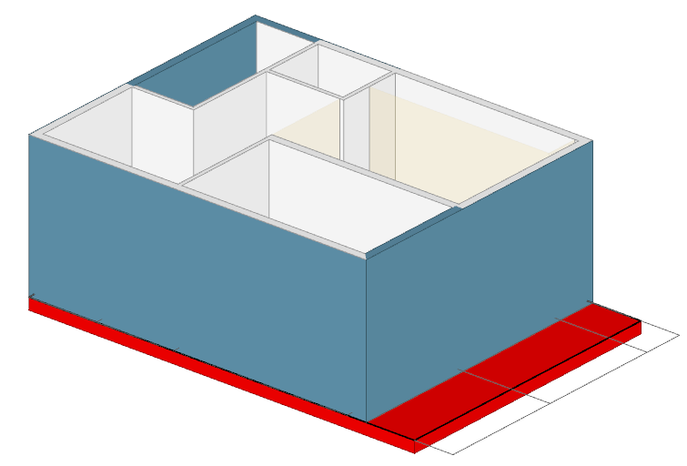
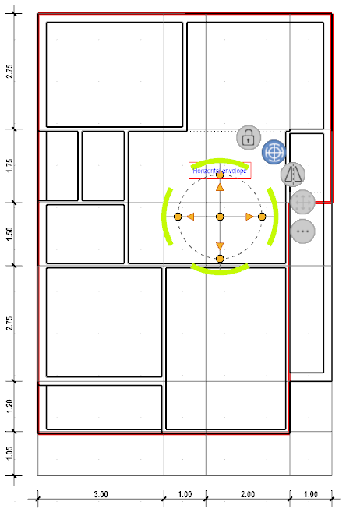 | 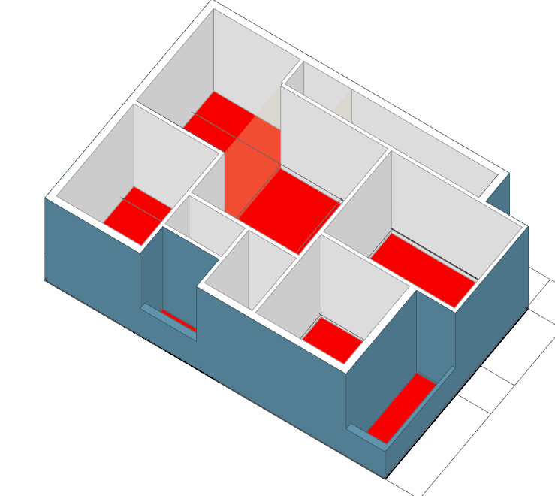
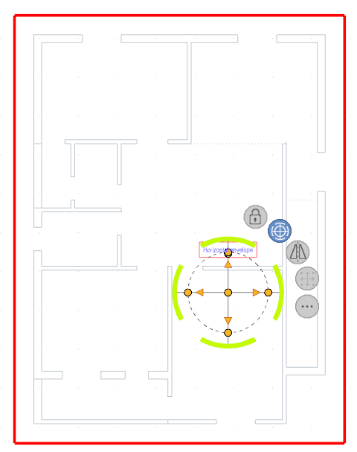 |  | 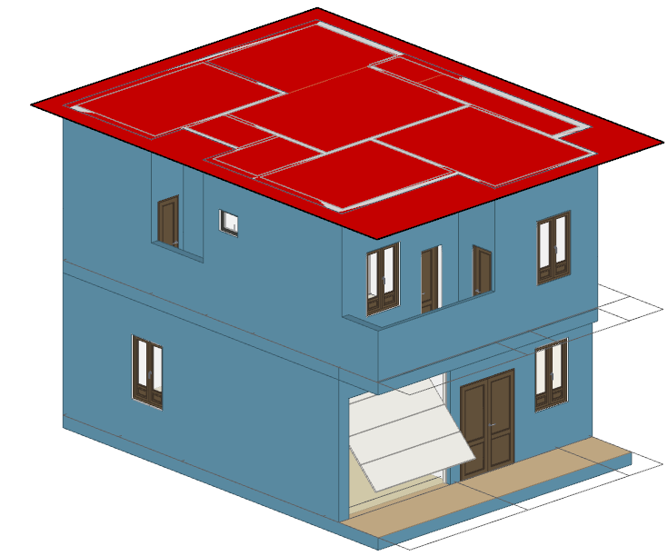

Roof
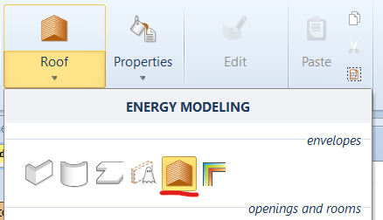 | 

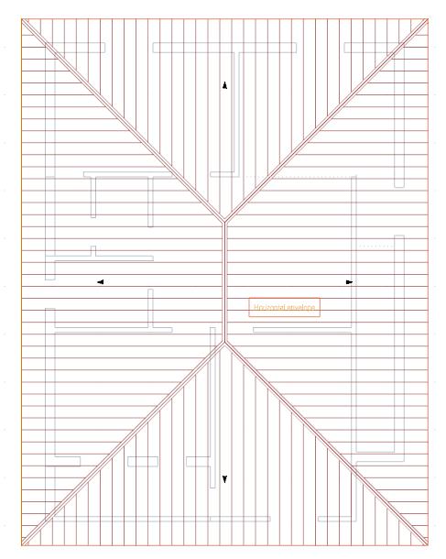 | 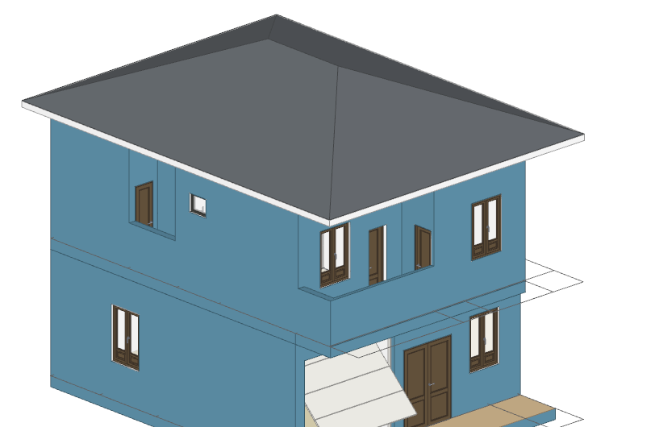

Doors & windows

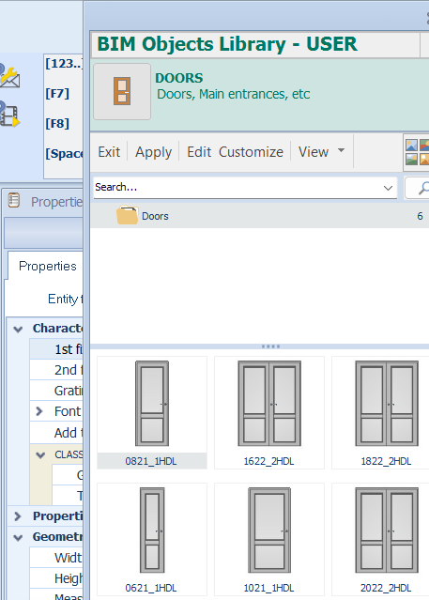 | 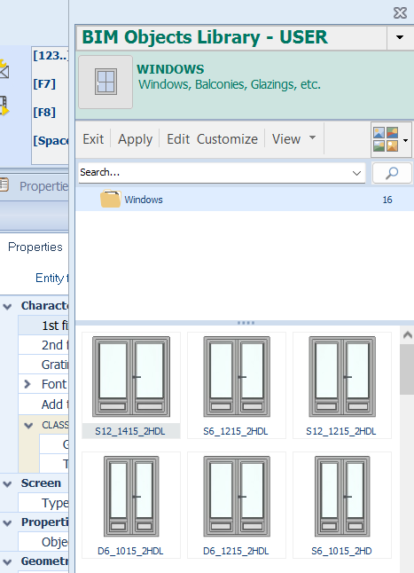

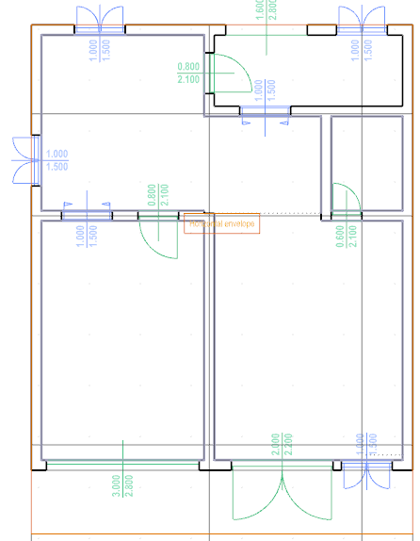 | 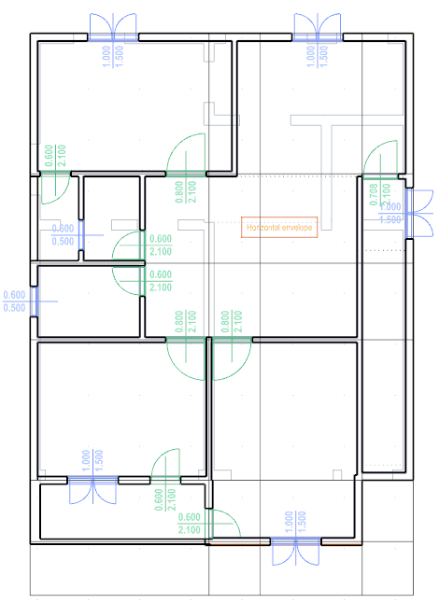

Holes
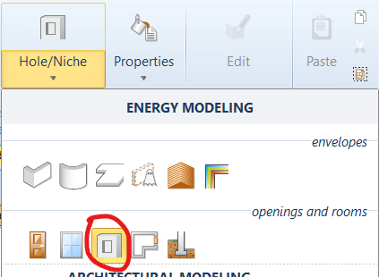 | 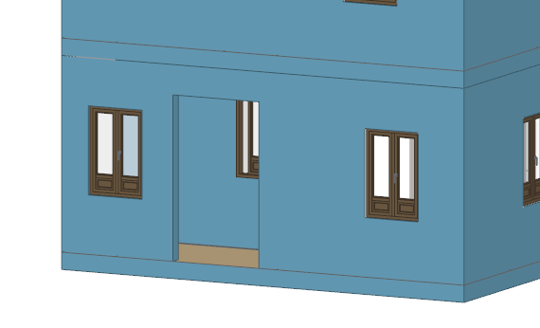

Completed model
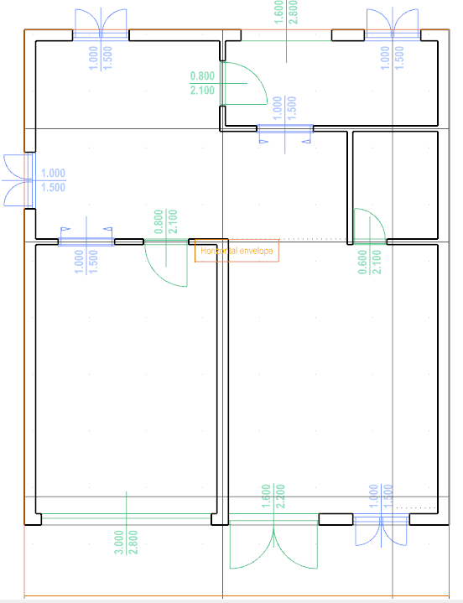 | 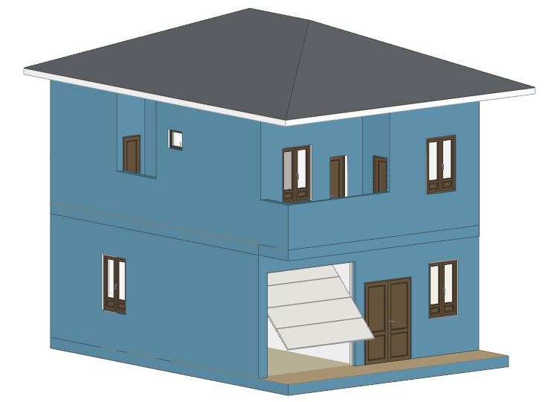
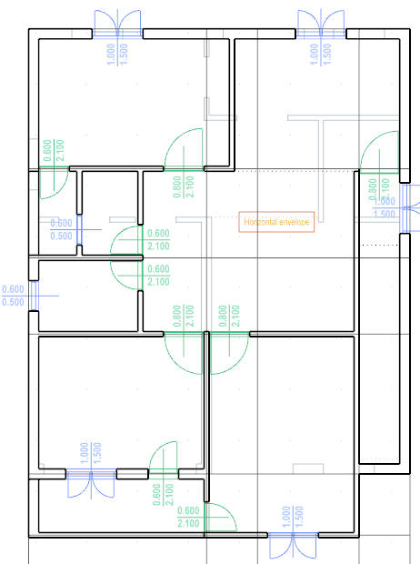 | 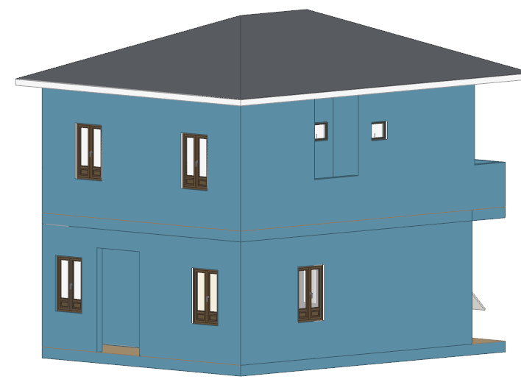
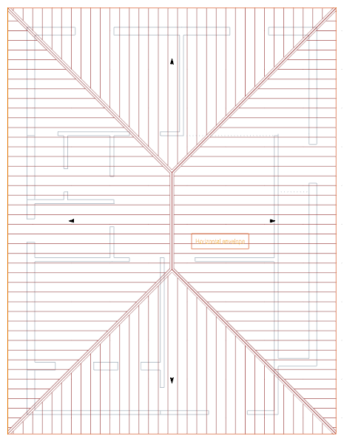 | 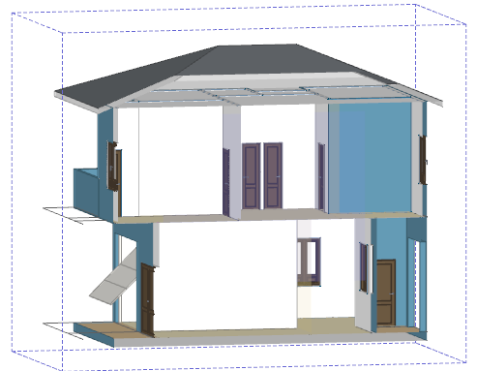

DETECT, CALCULATE AND ASSIGN THERMAL BRIDGE OBJECTS
To include the energy loss caused by weak areas in terms of thermal transmittance, the thermal bridge objects must be assigned to the model. Firstly, users detect where thermal bridge objects need to be considered. Secondly, thermal parameters of the detected thermal bridges are calculated by an add-in module integrated in TerMus-Plus software. The procedure is presented sequentially as followed

- Choose thermal bridge mode
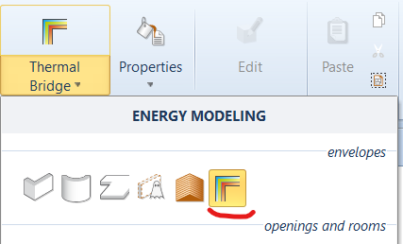
The software shows the weak positions within the building
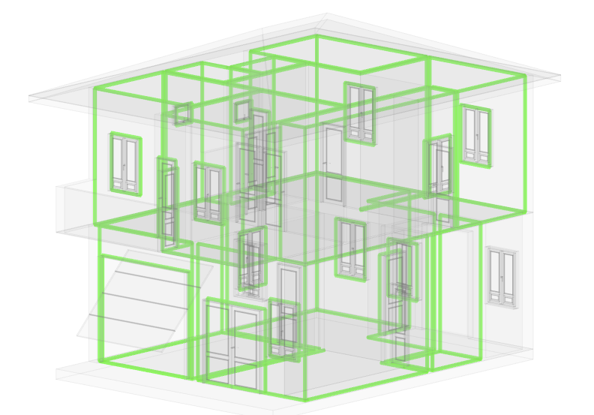
The weak positions are detected and assigned to be objects for calculation (the positioning lines turn to blue color)
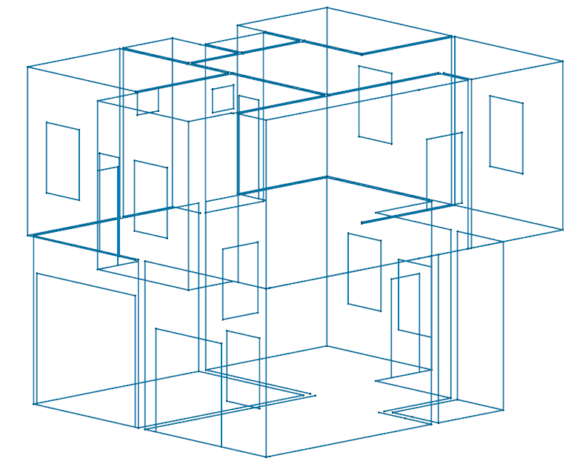
- Select thermal bridge object to calculate the thermal parameters and find equivalent thermal bridges to calculate simultaneously.
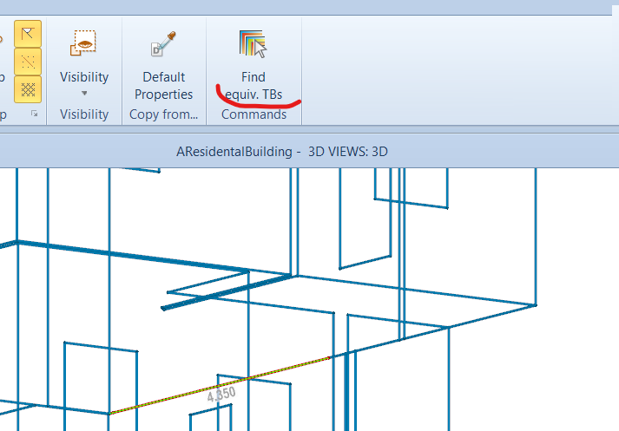
- Calculate the thermal parameters for the selected thermal bridge objects by the add-in module.
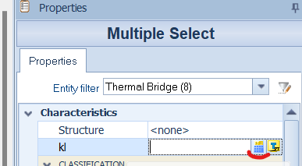
- Select the most appropriate type of connection for the current thermal bridge objects.
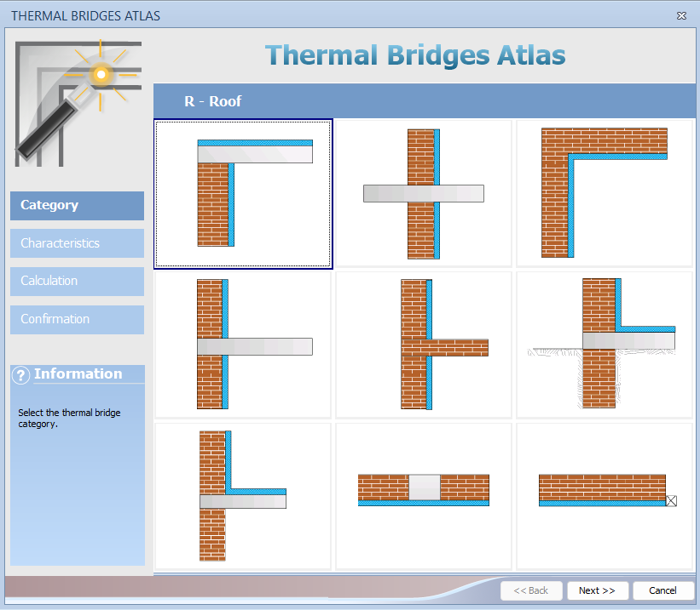
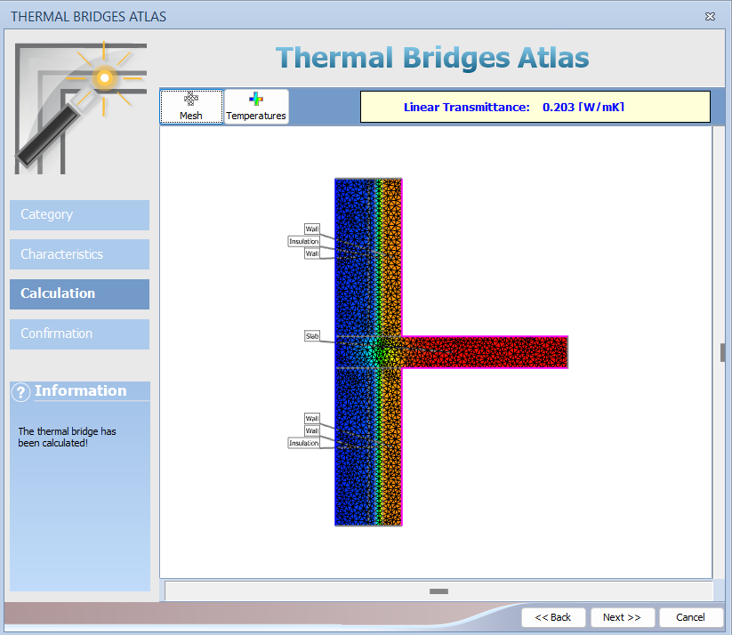
The thermal bridges whose thermal parameters have been calculated will be assigned a color different from the original blue color.

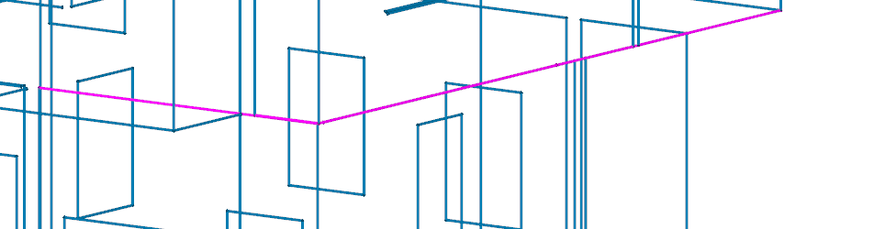

BOUNDARY CONDITIONS AND THERMAL DATA
The boundary conditions and thermal data are established to generally suit residential buildings in Mekong Delta region of Vietnam. This includes two aspects of common type of structures and popular conditions of usage.

III.1. Location and climate data
The weather data recorded in 2018 in An Giang province, Vietnam is imported to the software.
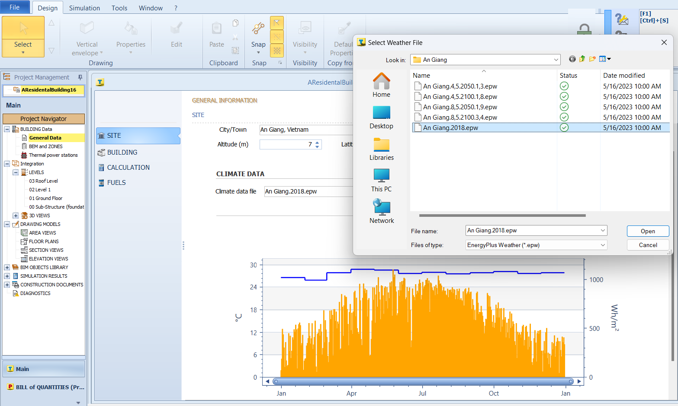
Next, the conditions related to the terrain of the building including wind protection and temperature of soil are selected.
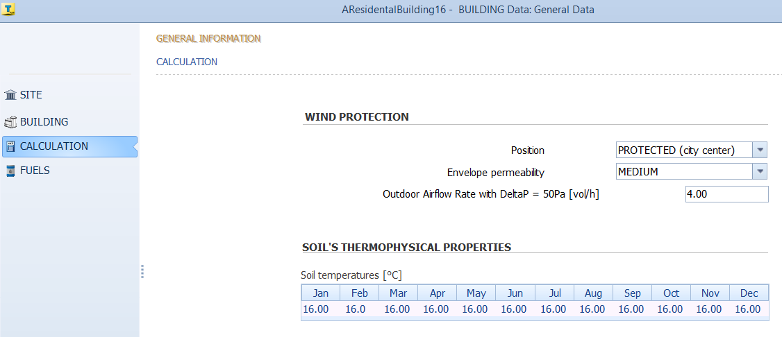
The technical parameters of the thermal power stations are set up (keep default in this project)
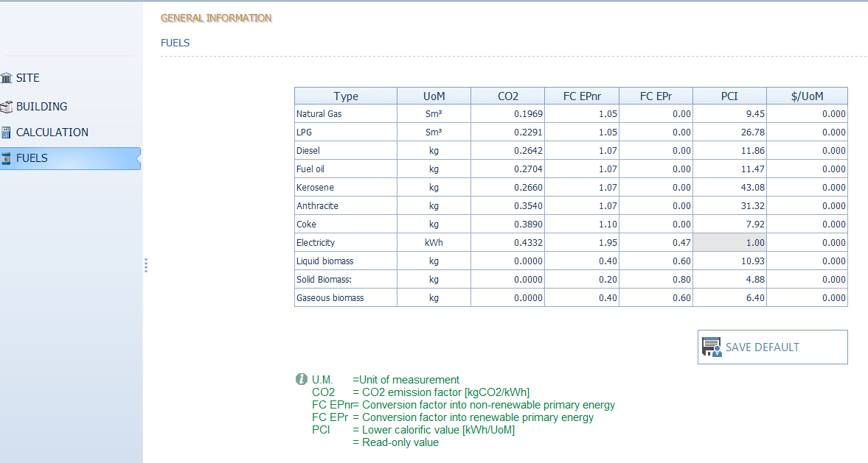

III.2. BEM and Zone for the building
The energy zones of the building are designed with four categories including heating, cooling, domestic hot water, and ventilation which will be assigned to corresponding areas of ground floor and 1st floor.
For each zone, the schedule of usage is defined over the year.
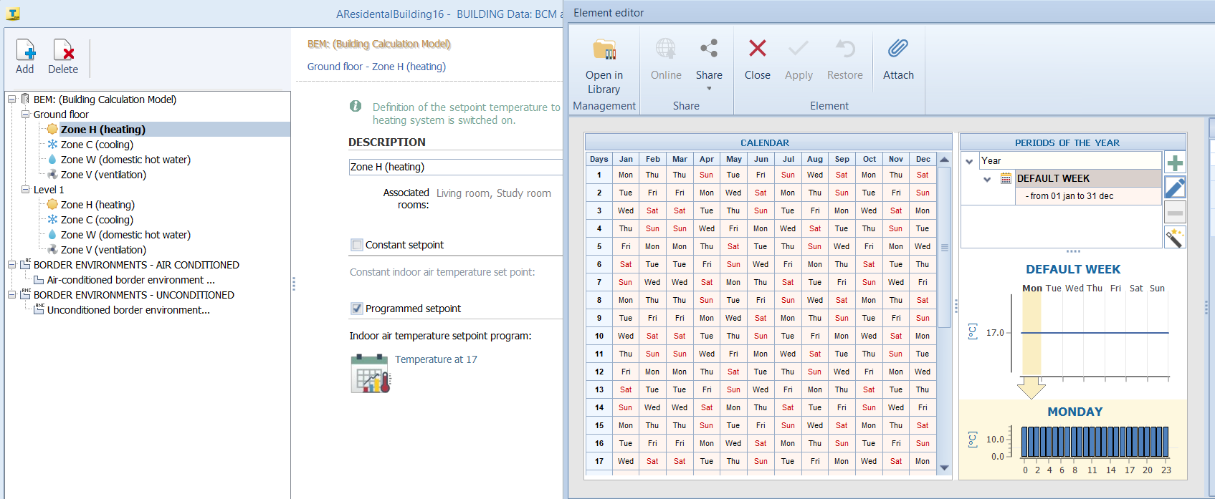
A similar procedure is followed for the remaining zones.

III.3. Thermal power station
Next, the thermal power station which operates of the energy zones defined above is set up. In this project, there are two power stations correspondingly distributed to two designed floors.
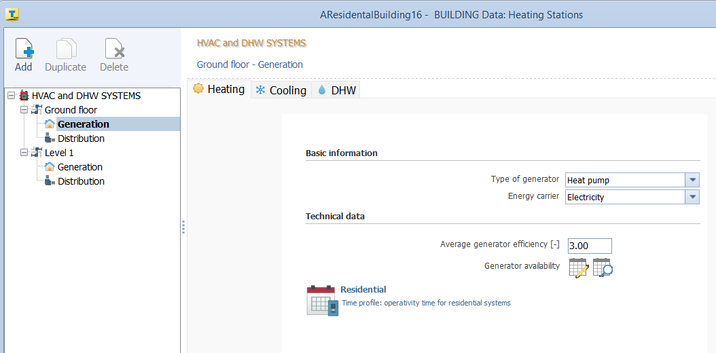
In the section “Generation”, information about the energy carrier and the schedule of the operation is defined respectively for heating, cooling, and domestic hot water.
After the information related to the generation of the station is defined, the station is correspondingly distributed to the designed floor.
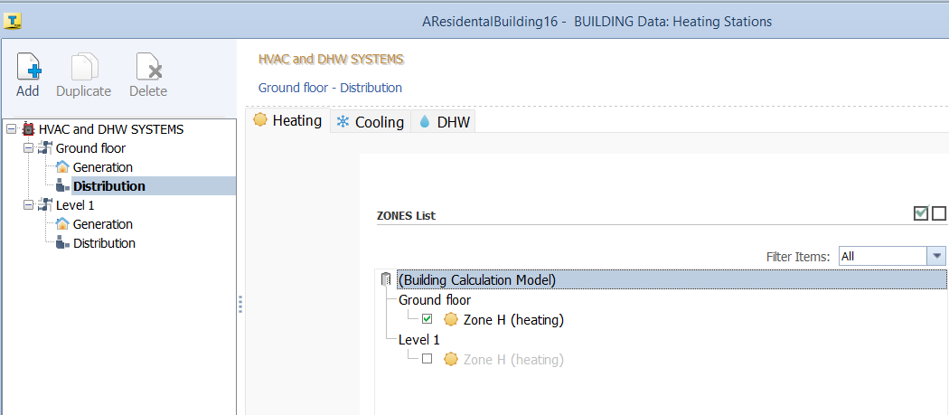

DEFINE AND ASSIGN FUNCTIONAL ZONES TO THE BUILDING
After the energy zones and stations are designated to meet the need of the function of the building, they are assigned to respective areas of the building.
There are two steps to complete this process. Firstly, functional rooms in the building are defined, as follow
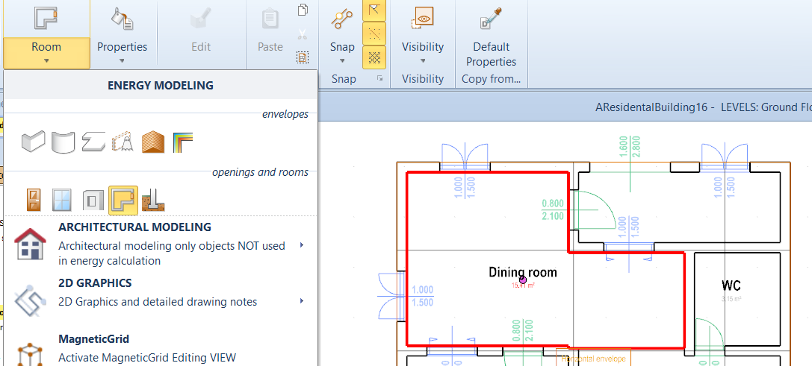

Secondly, each functional room is assigned the corresponding “subUnit” and “ZONE” in its properties pane provided by the software.
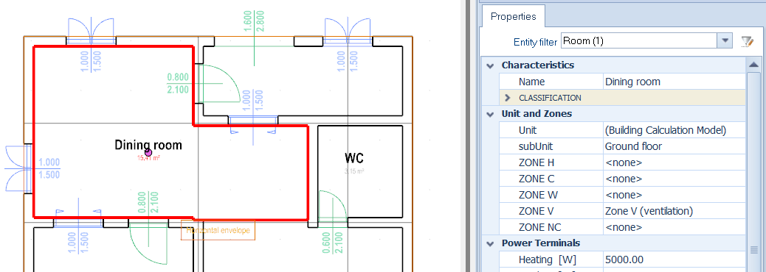
A similar procedure is followed for the remaining functional room of the building.

ANALYZE DIAGNOSTICS AND START SIMULATION
After finishing the model construction and the technical settings, diagnostics are analyzed to detect possible errors so that the simulation could be performed.

If no error is detected, the simulation can be started. The option among yearly, monthly, daily, and hourly calculation is selected before the simulation runs. In this project, the simulation is implemented with daily calculation.
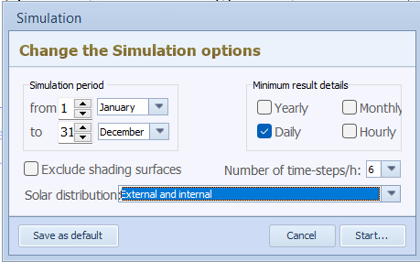

EXTRACT RESULTS
The simulated results include energy quantities related to the consumption of functional zones in the building and the generation of the thermal energy station.
The simulation provides results for yearly, monthly, daily, and hourly measurements. However, because the option selected for the simulation is daily calculation, the outcomes are summarized from daily to yearly figures.
In this project, the quantities measured for the whole year are the figures of consideration. Particularly, for functional usage of energy zones energy requirements and energy losses are considered, while for the energy generation of thermal power system CO₂ emissions are focused.
Total energy requirements and energy losses for a yearly calculation are shown as follows
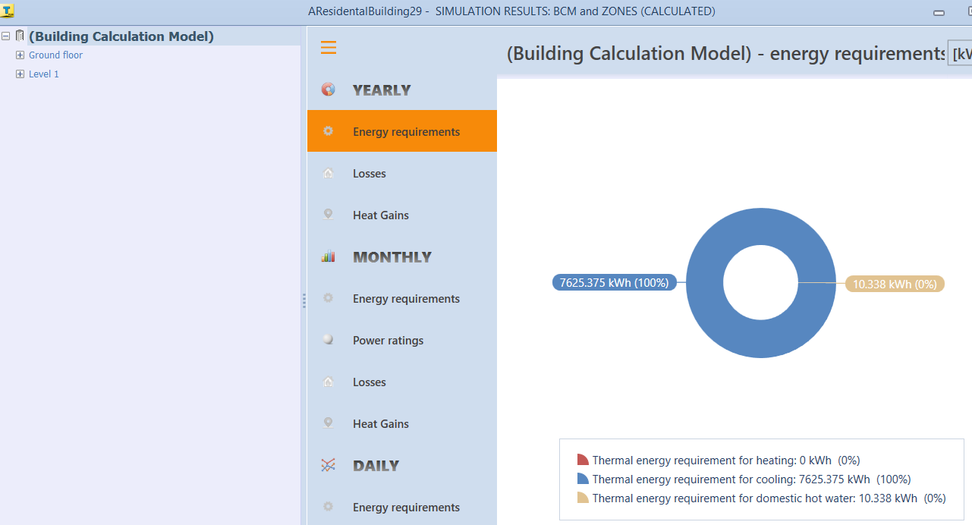
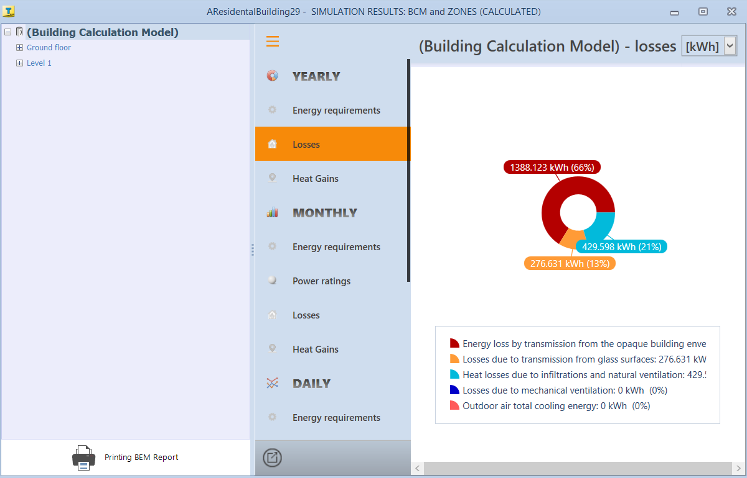
The yearly emissions of the thermal station for ground floor and first floor are respectively presented as below. The total emissions per year of the building is the sum of these figures.
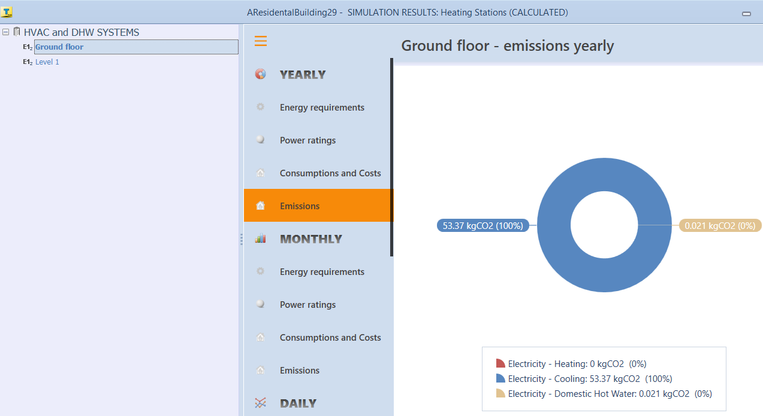
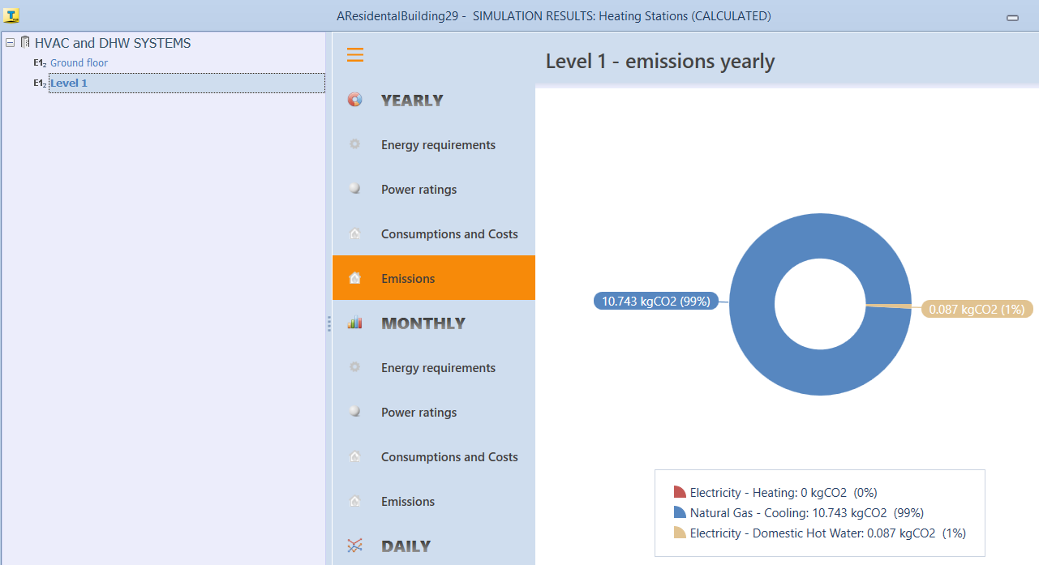

THEORY ABOUT THERMAL BRIDGE

VII.1. Energy used by households
Globally, the main energy consuming sectors are buildings, transport, industry and others, which clusters minor activities such as agriculture, forestry and fishing. In which, buildings were the most consuming sector, followed by industry and transport. Population growth built area increase, higher buildings services and comfort levels, together with the rise in time spent inside buildings have raised buildings consumption by 1.2%/yr since 2000. This upward trend has persisted even in periods of crisis such as the economic recession of 2008 or the COVID-19.
The residential sector accounts for the energy use in dwellings. Households use energy for various purposes: space and water heating, space cooling, cooking, lighting and electrical appliances and other end-uses (mainly covering uses of energy by households outside the dwellings themselves) (europa.eu).
According to JLC (The Journal of light construction), on average, the percentage allocation of household energy is as follow:
- More than half of the total annual energy goes to space heating and air conditioning.
- About 27%: water heating, lighting, and refrigeration combined.
- The remaining 21% to everything else (washers and dryers, cellphone chargers, computers, and all the other devices we use in a home that is used on heating and cooling).
The amount of energy that’s consumed for heating and cooling homes varies significantly by geographic location, house size, construction type, and the equipment and fuels used. But the majority percentage of household energy that is used on heating and cooling speaks loud and clear to the importance of understanding how heat moves through buildings.

VII.2. Essential concepts
Heat vs. Temperature
Heat is not the same as temperature. Heat is kinetic energy; temperature is a measurement of how intense that kinetic energy is.
Heat Transfer
Heat moves through building assemblies primarily in three ways: by conduction, by convection, and by radiation.
Conduction is the movement of heat energy directly through solid materials from molecule to molecule. The movement of the material plays no role in the transfer of heat.
Heat requirement
Heat requirement is the amount of cooling or heating that is necessary to maintain desired temperatures in a space.
Heat loss
Buildings lose heat through conduction during cold weather. The amount of heat gain or loss that occurs will depend on the specific conditions of the building, such as the insulation, size, and orientation. (Source: hvacprogramme.net)
The heat loss from a building can be calculated using the following formula:
Q = U x A x ΔT
Where:
Q – is the heat loss in BTUs per hour.
U – is the overall heat transfer coefficient.
A – is the area of the building envelope in square feet.
ΔT is the difference in temperature between the inside and outside of the building.
Heat gain
Buildings gain heat from sunlight, conduction through the walls, and internal heat sources such as people and electrical equipment.
The heat gain from a building can be calculated using the following formula:
Q = 1.1 x U x A x ΔT
Where:
- Q is the heat gain in BTUs per hour.
- U is the overall heat transfer coefficient.
- A is the area of the building envelope in square feet.
The function of a cooling system is to remove unwanted heat from a structure and relocate it to the outside. The function of the heating system is to replace heat lost through the heat transfer process. If heat gains exceed the losses (with consideration of storage effects), the building has a cooling load and energy must be applied to the air conditioning system to remove heat from the building. If heat losses exceed the gains, there is a heating load and energy must be used by a furnace or boiler to add heat to the space.

VII.3. Thermal bridge (cold bridge)

Defiition of Thermal bridge (cold bridge)
Heat always moves from warmer areas to colder areas. In winter, we heat the interior of a home, so the direction of heat flow is from inside to outside. In summer when it’s hotter outdoors, the direction is reversed. The thermal bridge happens when a particularly conductive (or poorly insulating) material allows heat flow across a thermal barrier. For example, studs within an insulated wall. The insulation on either side of a stud will do its job of limiting heat flow. But, the wooden stud, which has a much lower R-value, will not. These bridges can become expressways of heat loss.
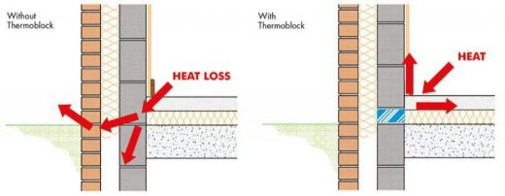
Concept of Thermal Bridge
(Source: Civil Engineering Quora)
Thermal bridges are well identified areas where weaknesses within a building’s structure cause heat and/or cold to be transferred at a substantially higher rate than through the surrounding envelope area. (Source: accasoftware)
If building is losing heat through thermal bridges, the efficacy of climate control system decreases and uses more energy. Furthermore, these bridges can create cold spots within walls where condensation can easily form. This moisture can produce a whole host of issues to the wall cavity mold and mildew or rot, to name a few. Excessive moisture also challenges the structural integrity of the wall.
Thermal bridging is most often caused by improper installation or by material choice/building design. An example of improper installation leading to thermal bridging is gaps in insulation, which allow heat to escape around the insulation and may also allow air leakage.
A thermal bridge occurs in all places where insulation does not connect properly, such as around exterior doors and windows, where the insulation is not optimally connected to floors or the door and window openings themselves.
Some examples of places where thermal bridges can occur:
- Transition from a wall to a window
- Eaves
- The points where the wall and the floor come together
- Wall-to-roof junctions
- Pipe and cable access holes in the building envelope
- Window and door reveals
- Steel wall links in masonry work, (e.g. cavity walls)

Types of thermal bridge (cold bridge)
Thermal bridges can generally be divided into:
- Repeating thermal bridges – occur when there are regular interruptions in the building fabric such as studs or wall ties.
- Linear (non-repeating) thermal bridges – occur where there are gaps in the insulation layer around openings such as windows or doors or where a more conductive material penetrates or bridges through the insulation layer.
- Geometrical thermal bridges – occur where two or three different planes meet such as junctions between the different building elements. These typically occur where the heat loss area is greater than the internal surface such as corners; and
- Point thermal bridges – are typically single penetrations in the thermal envelope of the building and can include fixings or fasteners, brackets for a canopy or in a rainscreen, a flue passing through a wall, or isolated steel beams or columns.

Energy loss because of thermal bridge (cold bridge)
Thermal bridging can be a major source of energy loss in homes and buildings, leading to higher utility bills.
Energy loss:
- Through the sidewalls of a home accounts: for nearly 35% of the total energy loss
- Windows (10%),
- Doors (15%),
- Foundation (15%),
- Roof (25%).

Thermal bridge (cold bridge) calculation
- Identify building component connections
- Individual thermal conductivities of the materials
- Heat transfer resistances
- Condition of the surfaces (roughness, colour and ventilation)
- Direction of heat flow
For calculating thermal bridges, it is first necessary to model the corresponding building component connections for a heat flow program. The individual thermal conductivities of the materials must also be given besides the geometry. Furthermore, boundary conditions for temperatures and heat transfer resistances should be selected. The norm DIN EN ISO 10211 is decisive for the calculation of thermal bridges in building engineering. The calculations of the Ψ-value and determination of the minimal interior surface temperature can be performed using the same model, but other boundary conditions should be selected in each case, as described below. (Source: https://passipedia.org/)

VII.4. Determining the thermal transmittance
The principle for calculating linear thermal transmittance is depicted in the illustration below. The Ψ-value represents the difference between the thermally interrupted component and the uninterrupted component that is assumed for the balance.
First the heat flow or the conductance L_{2d} is determined by means of the heat flow simulation. To determine the Ψ-value, L₀ is deducted from the conductance of the uninterrupted building component. It is essential that the linear reference is adhered to all throughout. If interior references are used in the context of energy balancing, then Ψ-values based on interior references must also be used. However, exterior dimensions are used more often in practice as these can easily be taken from plans and measurements. Exterior dimensions are therefore consistently used in the PHPP.
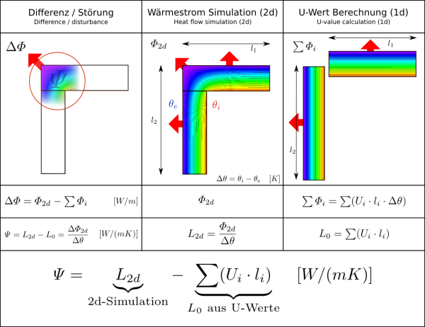

VII.5. Boundary conditions/ transfer resistances
Because the conductance is independent of the assumed boundary conditions for the temperatures, it does not matter which temperatures are set for the inside and outside as long as there is a temperature decline due to the building component. In practical terms, the same temperatures as those used for determining the minimum surface temperature are used. The heat transfer resistances to be used are more important as they are a measure of the heat exchange between the building component and the surrounding air. The influence of radiation exchange, thermal conductance and convection is combined in these, therefore they depend on the condition of the surfaces (roughness, colour and ventilation) and on the direction of the relevant heat flow through the building component among other things. A distinction is made between Rsi for the inside and Rse for the outside.

Thermal resistance  (m²·K)/W | Direction of heat flow
Thermal resistance  (m²·K)/W | Upwards | Horizontal | Downwards
Rsi | 0.10 | 0.13 | 0.17
Rse | 0.04 | 0.04 | 0.04

VII.6. Determining the minimum surface temperature and the f factor
The procedure for determining the surface temperatures is similar and can usually take place using the same model as for calculating the Ψ-value. However, a higher transfer resistance Rsi is used for the inside space. The reason for this is that wardrobes, wall coverings, curtains and the like reduce convection and radiation exchange at corners, edges and walls, which ultimately leads to lower surface temperatures. That is why in order to stay on the safe side, the increased transfer resistance of Rsi = 0.25 (m²·K)/W is used for the entire interior space (DIN 4108-2, Section 6.3). Even higher transfer resistances are recommended in the Technical Report 4108-8 :
- Rsi,äq,ä = 0.50 (m²·K)/W for areas behind free-standing cabinets
- Rsi,äq,ä = 1.00 (m²·K)/W for areas behind fitted cupboards

VII.7. Boundary conditions for temperatures
Because temporal changes in temperatures and thermal capacities of the materials are not taken into account in the steady-state simulations, fixed boundary conditions for the temperatures must be used, which ultimately leads to a static temperature field in the building component. The minimum surface temperature can then be read here; however this only refers to the respective temperature difference between the set indoor temperature and the outdoor temperature. In the norm DIN 4108-2 (Section 6.3) the following boundary conditions for the temperature are given:
- θi = 20 °C for indoor air temperature
- θe = −5 °C for outdoor air temperature
It quickly becomes clear that the minimum surface temperatures ascertained thus do not have any informative value. The above-mentioned boundary conditions for the temperature are rough estimates at best and cannot really depict realistic temperature differences. The uncertainties with reference to the climate-dependent outdoor conditions and the actual temperatures on the inside are too high. If the dynamic simulations are dispensed with, then this issue can at least be circumvented with the aid of the dimensionless temperature factor fRsi in accordance with DIN EN ISO 10211 (Section 11).
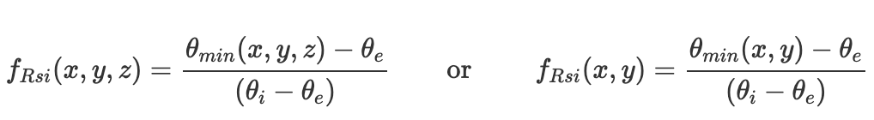
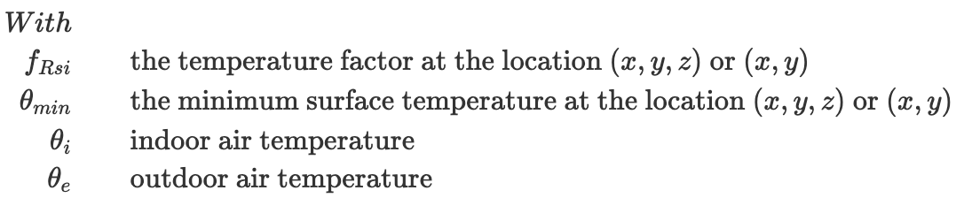
The factor determined with this equation now makes it possible to calculate the temperature at the corresponding place for any temperature difference without the need for further heat flow simulations. With the aid of the fRsi factor, conclusions can be drawn about any potential condensation formation and mould growth.

VII.8. Example of a thermal bridge calculation
A thermal bridge calculation for a verge detail is shown below.
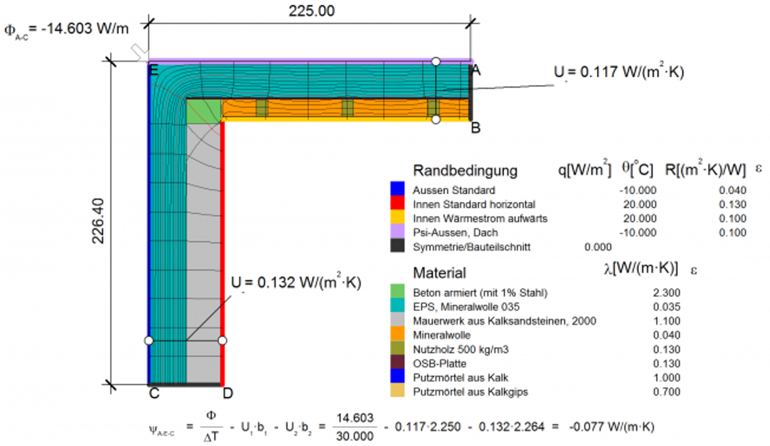
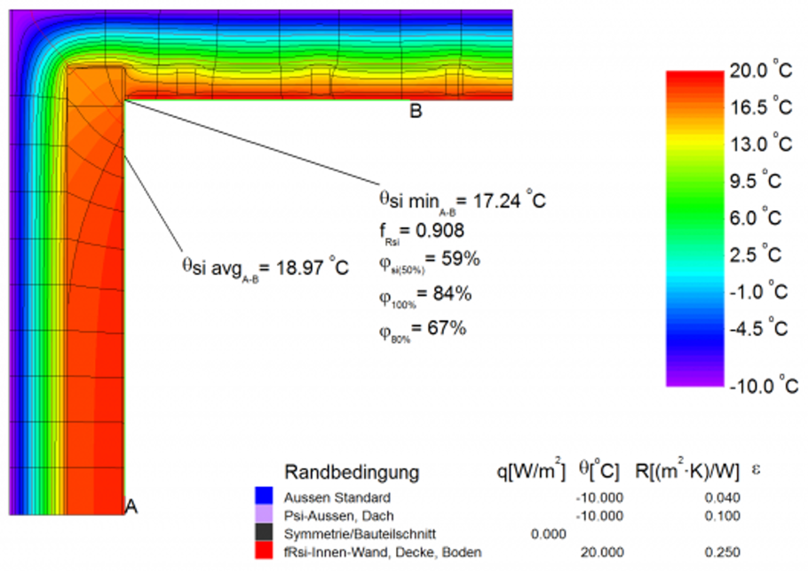

DESIGNED VARIABLES FOR MACHINE LEARNING MODEL

VIII.1. Object library for case-to-case simulations
Slab index | Titles | Thickness  (mm)
1 | Concrete slab_130 | 130
2 | Concrete slab_150 | 150
3 | Concrete slab_200 | 200

Wall index | Titles | Thickness  (mm)
1 | Brick Wall_100 | 100
2 | Brick Wall_150 | 150
3 | Brick Wall_200 | 200
4 | Brick Wall_250 | 250

Windows  index | Titles | Area  (m²) | No.  layers
1 | S6_1015_2HDL | 1.5 | 1
2 | S6_1215_2HDL | 1.8 | 1
3 | S6_1415_2HDL | 2.1 | 1
4 | D6_1015_2HDL | 1.5 | 2
5 | D6_1215_2HDL | 1.8 | 2
6 | D6_1415_2HDL | 2.1 | 2

Primary Doors index | Titles | Area  (m²)
1 | 1622_2HDL | 3.52
2 | 1822_2HDL | 3.96
3 | 2022_2HDL | 4.4

Secondary Doors  index | Titles | Area  (m²)
1 | 0621_1HDL | 1.26
2 | 0821_1HDL | 1.68

Ceilings | Titles | Thickness  (mm)
1 | Panels_10 | 11
2 | Panels_13 | 14
3 | Panels_15 | 16.5

VIII.2. Randomly creating scenarios and case-to-case simulating
After creating an object library for case-to-case simulations, different scenarios are generated by randomly combining the objects in the created library. The combination is presented as follows:
Scenarios | Designed variables
Scenarios | gr_slab | ceiling | ex_wall | in_wall | ex_win | prim_door | sec_door
1 | 2 | 1 | 3 | 2 | 5 | 2 | 1
2 | 3 | 2 | 2 | 2 | 5 | 1 | 2
3 | 3 | 2 | 2 | 2 | 6 | 3 | 2
4 | 2 | 2 | 2 | 1 | 3 | 3 | 1
5 | 3 | 2 | 3 | 1 | 5 | 2 | 1
6 | 2 | 1 | 3 | 1 | 5 | 3 | 1
7 | 3 | 3 | 2 | 1 | 2 | 3 | 1
8 | 1 | 3 | 3 | 2 | 5 | 3 | 1
9 | 1 | 2 | 2 | 1 | 3 | 2 | 2
10 | 2 | 3 | 3 | 3 | 2 | 3 | 1
11 | 3 | 3 | 4 | 1 | 3 | 3 | 2
12 | 1 | 1 | 3 | 3 | 5 | 2 | 2
13 | 1 | 3 | 3 | 3 | 2 | 3 | 1
14 | 2 | 1 | 2 | 3 | 4 | 2 | 2
15 | 3 | 2 | 3 | 1 | 3 | 3 | 2
16 | 1 | 2 | 2 | 3 | 1 | 3 | 2
17 | 2 | 1 | 2 | 2 | 2 | 2 | 2
18 | 2 | 1 | 4 | 1 | 6 | 2 | 1
19 | 2 | 1 | 3 | 3 | 5 | 3 | 1
20 | 1 | 1 | 3 | 2 | 3 | 2 | 2
21 | 2 | 3 | 4 | 2 | 1 | 1 | 2
22 | 3 | 3 | 3 | 2 | 2 | 2 | 1
23 | 1 | 2 | 3 | 3 | 5 | 3 | 1
24 | 1 | 1 | 2 | 2 | 5 | 3 | 1
25 | 3 | 1 | 2 | 3 | 2 | 2 | 1
26 | 1 | 1 | 2 | 1 | 5 | 3 | 2
27 | 2 | 3 | 3 | 2 | 3 | 1 | 1
28 | 3 | 3 | 2 | 1 | 1 | 2 | 2
29 | 1 | 3 | 4 | 1 | 5 | 3 | 2
30 | 3 | 1 | 4 | 3 | 1 | 2 | 2

VIII.3. Numerical data for ML model

a.. Input variables
 | Slab  Thickness | Ceiling  thickness | ex_wall  thickness | in_wall  thickness | ex_win  area | ex_win  layers | prim_door  area | sec_door  area
 | x₁ | x₂ | x₃ | x₄ | x₅ | x₆ | x₇ | x₈
1 | 150 | 11 | 200 | 150 | 1.8 | 2 | 3.96 | 1.26
2 | 200 | 14 | 150 | 150 | 1.8 | 2 | 3.52 | 1.68
3 | 200 | 14 | 150 | 150 | 2.1 | 2 | 4.4 | 1.68
4 | 150 | 14 | 150 | 100 | 2.1 | 1 | 4.4 | 1.26
5 | 200 | 14 | 200 | 100 | 1.8 | 2 | 3.96 | 1.26
6 | 150 | 11 | 200 | 100 | 1.8 | 2 | 4.4 | 1.26
7 | 200 | 16.5 | 150 | 100 | 1.8 | 1 | 4.4 | 1.26
8 | 130 | 16.5 | 200 | 150 | 1.8 | 2 | 4.4 | 1.26
9 | 130 | 14 | 150 | 100 | 2.1 | 1 | 3.96 | 1.68
10 | 150 | 16.5 | 200 | 200 | 1.8 | 1 | 4.4 | 1.26
11 | 200 | 16.5 | 250 | 100 | 2.1 | 1 | 4.4 | 1.68
12 | 130 | 11 | 200 | 200 | 1.8 | 2 | 3.96 | 1.68
13 | 130 | 16.5 | 200 | 200 | 1.8 | 1 | 4.4 | 1.26
14 | 150 | 11 | 150 | 200 | 1.5 | 2 | 3.96 | 1.68
15 | 200 | 14 | 200 | 100 | 2.1 | 1 | 4.4 | 1.68
16 | 130 | 14 | 150 | 200 | 1.5 | 1 | 4.4 | 1.68
17 | 150 | 11 | 150 | 150 | 1.8 | 1 | 3.96 | 1.68
18 | 150 | 11 | 250 | 100 | 2.1 | 2 | 3.96 | 1.26
19 | 150 | 11 | 200 | 200 | 1.8 | 2 | 4.4 | 1.26
20 | 130 | 11 | 200 | 150 | 2.1 | 1 | 3.96 | 1.68
21 | 150 | 16.5 | 250 | 150 | 1.5 | 1 | 3.52 | 1.68
22 | 200 | 16.5 | 200 | 150 | 1.8 | 1 | 3.96 | 1.26
23 | 130 | 14 | 200 | 200 | 1.8 | 2 | 4.4 | 1.26
24 | 130 | 11 | 150 | 150 | 1.8 | 2 | 4.4 | 1.26
25 | 200 | 11 | 150 | 200 | 1.8 | 1 | 3.96 | 1.26
26 | 130 | 11 | 150 | 100 | 1.8 | 2 | 4.4 | 1.68
27 | 150 | 16.5 | 200 | 150 | 2.1 | 1 | 3.52 | 1.26
28 | 200 | 16.5 | 150 | 100 | 1.5 | 1 | 3.96 | 1.68
29 | 130 | 16.5 | 250 | 100 | 1.8 | 2 | 4.4 | 1.68
30 | 200 | 11 | 250 | 200 | 1.5 | 1 | 3.96 | 1.68

b. Output
Energy requirement | Energy losses | Heat gain | CO2 emission
y₁ | y₂ | y₃ | y₄
22688.102 | 1282.381 | 1375.282 | 245.302
23861.6832 | 1408.189 | 1464.641 | 257.605
23859.006 | 1597.467 | 1790.218 | 257.577
25316.238 | 3245.01 | 4360.541 | 272.854
23022.892 | 1327.051 | 1470.36 | 248.812
23172.942 | 1276.432 | 1375.857 | 250.385
24983.143 | 2705.106 | 3533.284 | 269.362
22550.133 | 1274.038 | 1375.121 | 243.855
25357.733 | 3240.836 | 4631.209 | 273.289
22772.907 | 2666.802 | 3536.087 | 246.191
22679.721 | 3210.935 | 4371.967 | 245.214
22308.465 | 1272.441 | 1373.461 | 241.322
22821.129 | 2648.337 | 3525.179 | 246.696
23518.069 | 1361.941 | 1373.831 | 254.003
23928.036 | 3224.918 | 4377.178 | 258.301
23942.982 | 2160.649 | 2682.957 | 258.457
24711.759 | 2747.71 | 3523.699 | 266.517
22058.46 | 1469.074 | 1790.509 | 238.701
22214.658 | 1279.267 | 1374.112 | 240.339
23678.067 | 3219.737 | 4368.247 | 255.68
21817.472 | 2070.682 | 2693.81 | 236.175
23159.262 | 2658.712 | 3530.605 | 250.241
22189.173 | 1273.917 | 1373.8 | 240.071
24079.786 | 1355.751 | 1374.222 | 259.892
24153.804 | 2704.972 | 3515.808 | 260.667
24604.922 | 1349.086 | 1374.984 | 265.397
23470.556 | 3227.318 | 4369.871 | 253.505
24841.554 | 2367.138 | 3055.922 | 267.877
21836.148 | 1220.4 | 1372.777 | 236.37
21489.245 | 2076.622 | 2683.91 | 232.734

NEURAL NETWORKS MODEL FOR ENERGY PREDICTIONS

IX.1. Neural network development
Preliminary architecture for the Neural Network model:
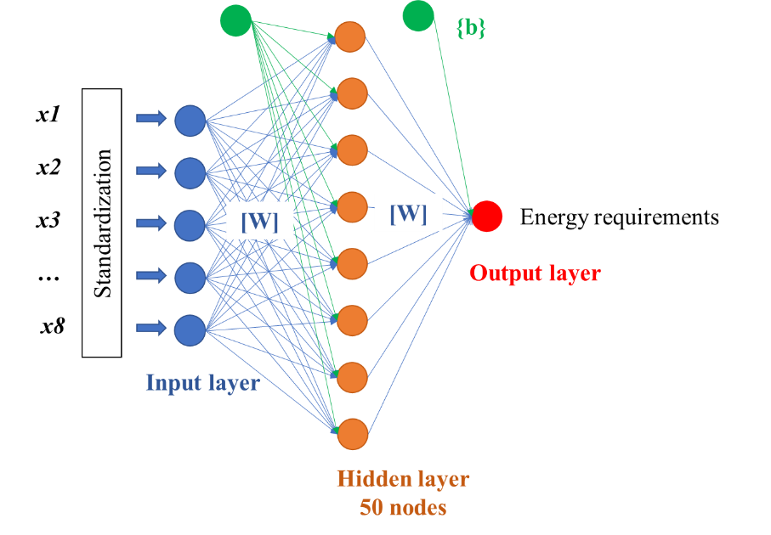 | + No. hidden layer: 1  + No. nodes: 50  + Activation: LeakyReLU  + Optimizer: Adamax (0.002)  + Batch size: 2  + Train/test: 24/6 (samples)
Model fitting 1
Training samples: 6 30; Testing samples: 1 5
Model name: ‘MLmodel_15.h5’
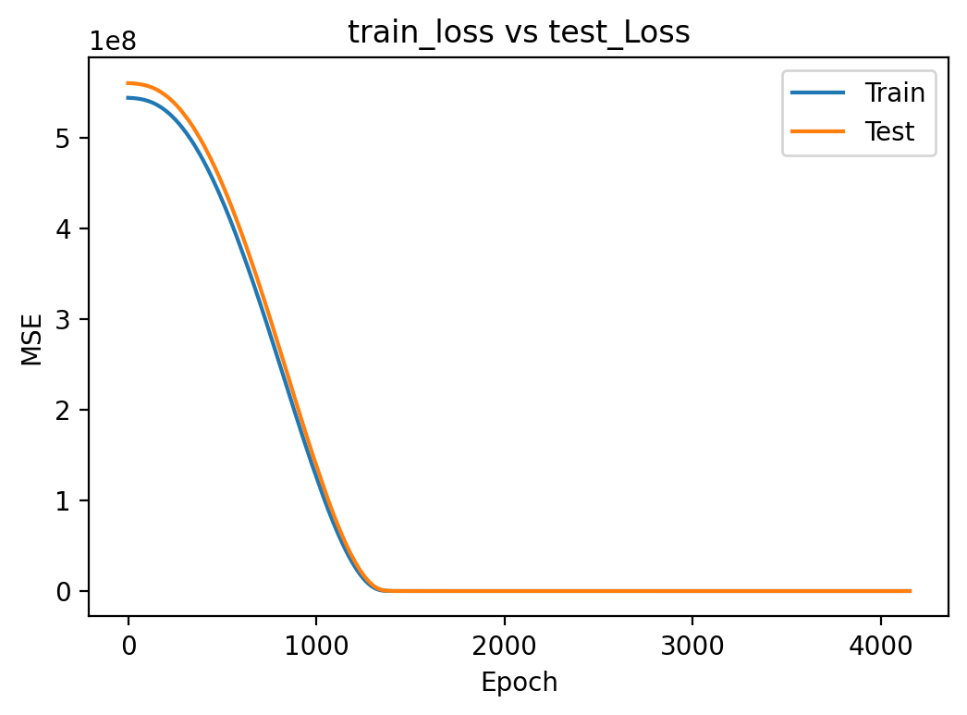  Training history | 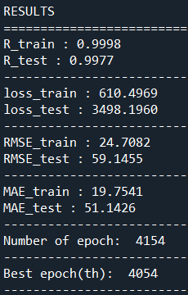  $$error_{train}=\frac{{RMSE}_{train}}{\overset{̿}{EnR}}=0.106\%$$  $$error_{test}=\frac{{RMSE}_{test}}{\overset{̿}{EnR}}=0.253\%$$

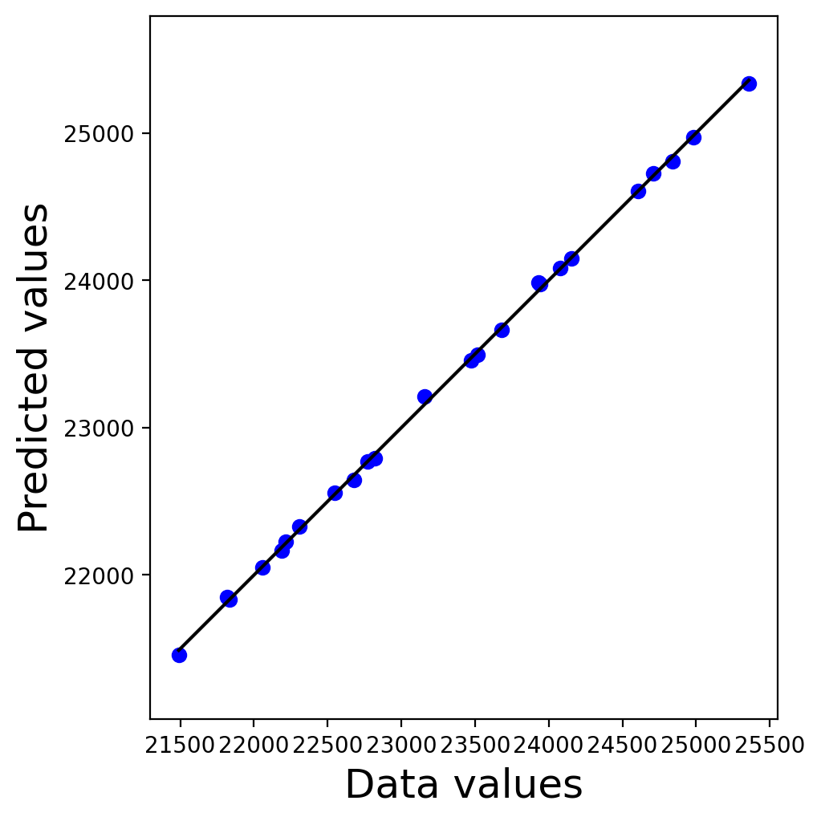  R = 0.9998 | 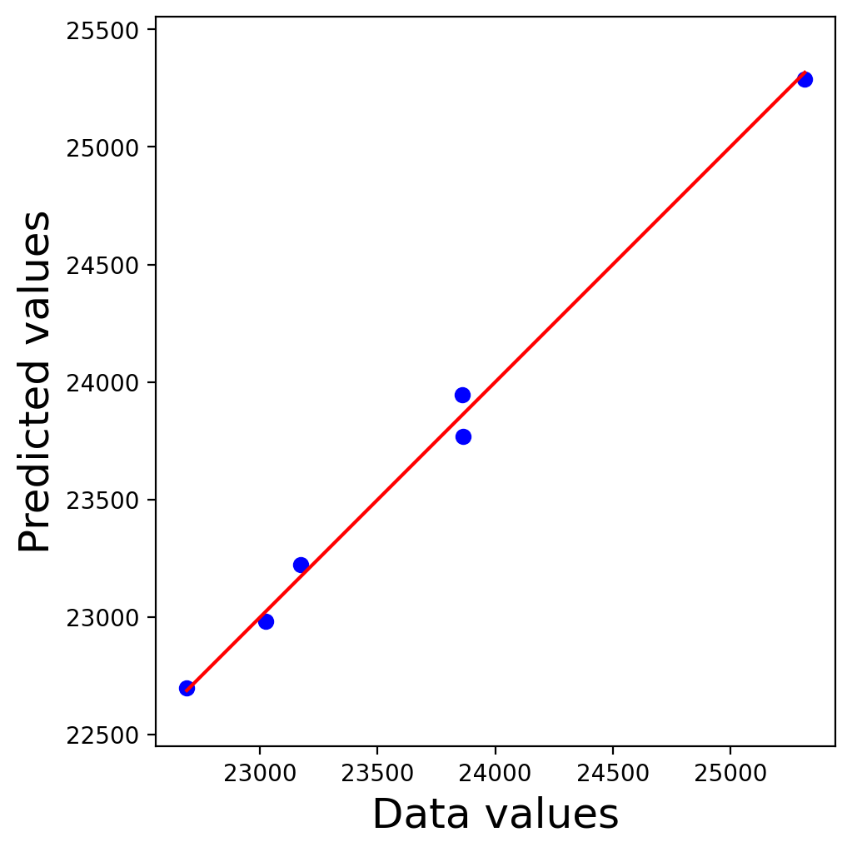  R = 0.9977

Model training 2
Training samples: [1 12] $∪$ [19 30]; Testing samples: 13 18
Model name: ‘MLmodel_leakyrelu_3.h5’
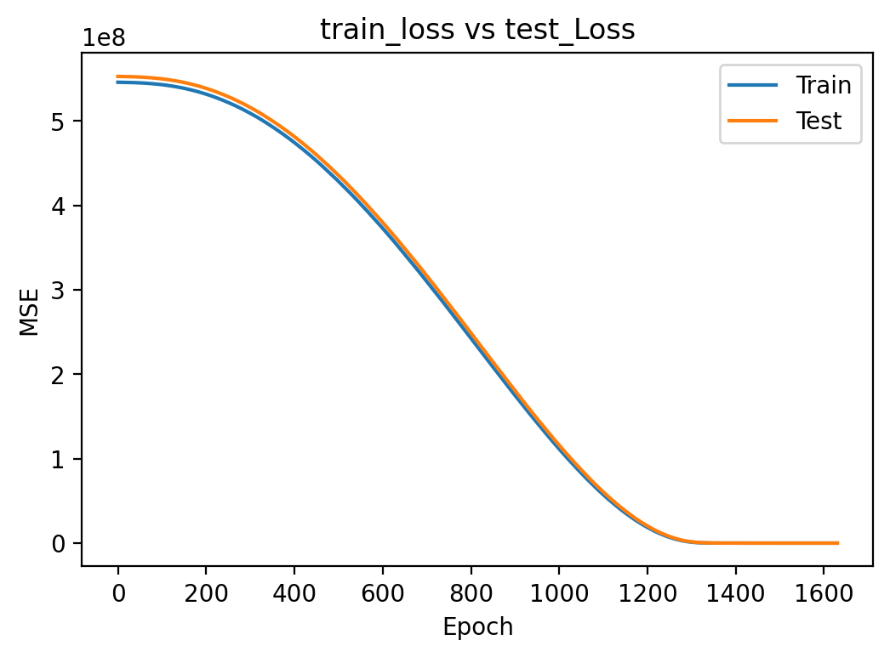  Training history | 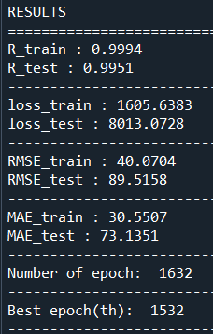  $$error_{train}=\frac{{RMSE}_{train}}{\overset{̿}{EnR}}=0.171\%$$  $$error_{test}=\frac{{RMSE}_{test}}{\overset{̿}{EnR}}=0.383\%$$

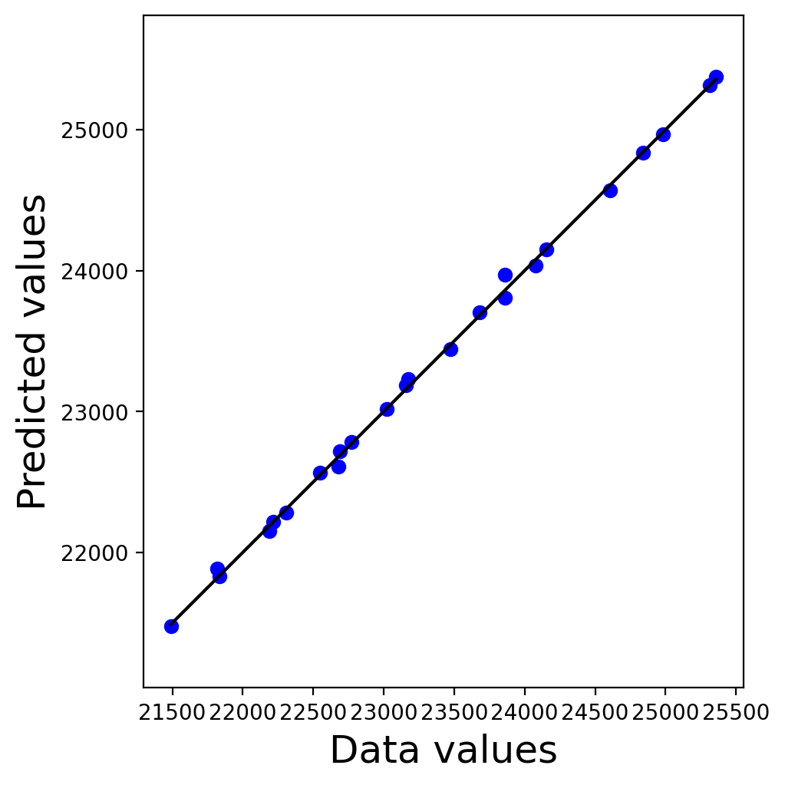  R = 0.9993 | 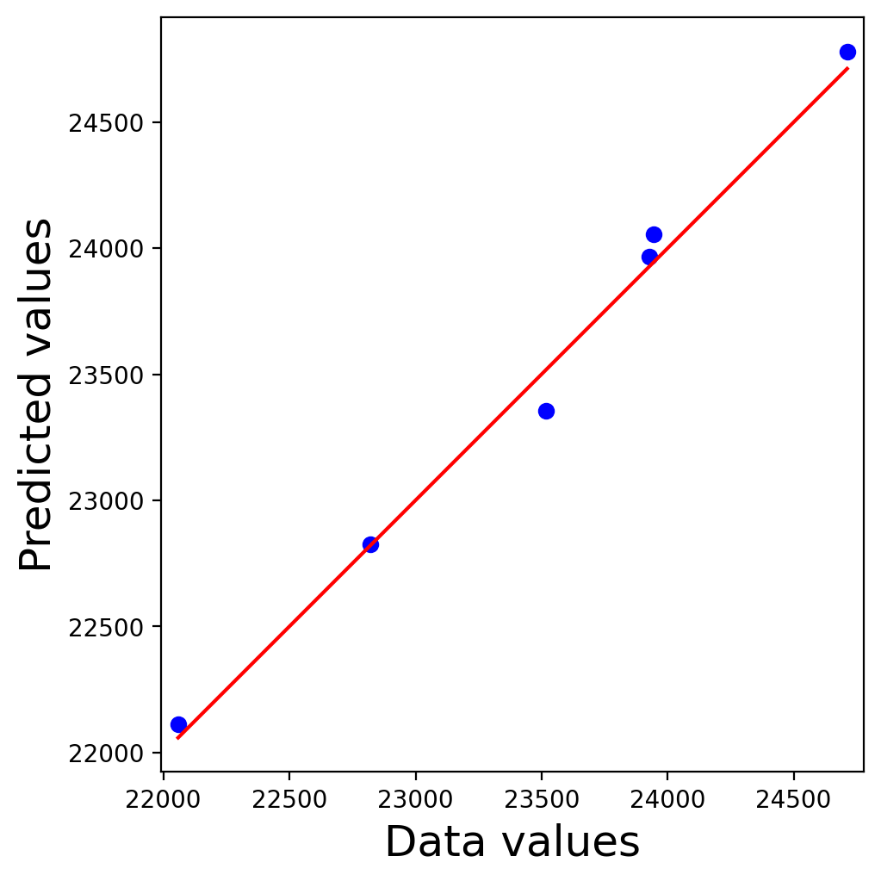  R = 0.9959

IX.2. Relative importance analysis

Connection Weights method (2002) (proposed by Julian D. Olden, Donald A. Jackson [1])
The connection weights of an input parameter to the hidden nodes are multiplied by the connection weights of the hidden nodes to the output node in a one-by-one correspondence manner. This operation is continuously performed for all the input parameters. Afterwards, the sums of the products according to each predictor are calculated, from which the relative importance of the predictors can be interpreted [2]. The method is step-by-step described by taking model training 1 as example, as follows:
Step 1: extracting matrix of weights of the Neural Network model
 | X1 | X2 | X3 | X4 | X5 | X6 | X7 | X8 | Output
 | Slab thickness | Ceiling thickness | External wall thickness | Internal wall thickness | Window area | Window layers | Main door area | Internal door area | Energy requirement
H_node 1 | -0.5162 | 0.0010 | -0.9769 | -0.4584 | 0.3150 | 0.2823 | 0.0858 | 0.5281 | 27.3943
H_node 2 | -0.2905 | -0.0006 | 1.2061 | 0.8704 | 0.0574 | 0.0343 | 0.0984 | -0.2040 | -26.0602
H_node 3 | -0.4984 | 0.2077 | 1.2152 | 0.8678 | -0.0788 | -0.0534 | 0.0022 | -0.2538 | -26.2705
… | … | … | … | … | … | … | … | … | …
H_node 49 | -1.5504 | -1.5972 | -1.5372 | 0.5099 | 0.1770 | 1.1553 | -0.1176 | -0.8734 | 22.5115
H_node 50 | -0.4653 | 0.2227 | 1.1449 | 0.9154 | -0.1212 | -0.0533 | -0.0243 | -0.2075 | -26.1088

Step 2: calculating the contribution of each input variable j^{th} to the output via each hidden node i^{th}
$$P_{ij}=w_{ij}w_{oi}$$
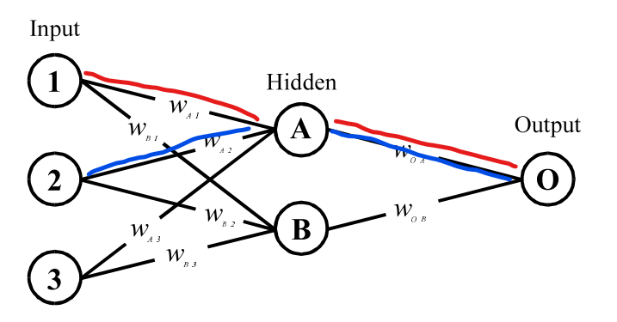
 | X1 | X2 | X3 | X4 | X5 | X6 | X7 | X8
 | Slab thickness | Ceiling thickness | External wall thickness | Internal wall thickness | Window area | Window layers | Main door area | Internal door area
H_node 1 | -14.1400 | 0.0283 | -26.7623 | -12.5568 | 8.6292 | 7.7345 | 2.3513 | 14.4679
H_node 2 | 7.5705 | 0.0164 | -31.4316 | -22.6834 | -1.4961 | -0.8941 | -2.5631 | 5.3174
H_node 3 | 13.0927 | -5.4576 | -31.9252 | -22.7981 | 2.0713 | 1.4033 | -0.0578 | 6.6682
… | … | … | … | … | … | … | … | …
H_node 49 | -34.9024 | -35.9558 | -34.6047 | 11.4777 | 3.9844 | 26.0082 | -2.6483 | -19.6625
H_node 50 | 12.1495 | -5.8151 | -29.8926 | -23.9006 | 3.1640 | 1.3907 | 0.6334 | 5.4164

Step 3: determining the relative contribution of each input variable j^{th} to the output of each hidden node i^{th}
$$Q_{ij}=\frac{\left|P_{ij}\right|}{\sum_{j}{\left|P_{ij}\right|}}$$
 | X1 | X2 | X3 | X4 | X5 | X6 | X7 | X8
 | Slab thickness | Ceiling thickness | External wall thickness | Internal wall thickness | Window area | Window layers | Main door area | Internal door area
H_node 1 | 0.1631 | 0.0003 | 0.3088 | 0.1449 | 0.0996 | 0.0892 | 0.0271 | 0.1669
H_node 2 | 0.1052 | 0.0002 | 0.4367 | 0.3152 | 0.0208 | 0.0124 | 0.0356 | 0.0739
H_node 3 | 0.1568 | 0.0654 | 0.3825 | 0.2731 | 0.0248 | 0.0168 | 0.0007 | 0.0799
… | … | … | … | … | … | … | … | …
H_node 49 | 0.2062 | 0.2124 | 0.2045 | 0.0678 | 0.0235 | 0.1537 | 0.0156 | 0.1162
H_node 50 | 0.1475 | 0.0706 | 0.3629 | 0.2902 | 0.0384 | 0.0169 | 0.0077 | 0.0658

Step 4: summing up the relative contribution of each input variable to the output through all hidden nodes.
$$S_{j}=\sum_{i}{Q_{ij}}$$
 | X1 | X2 | X3 | X4 | X5 | X6 | X7 | X8
 | Slab thickness | Ceiling thickness | External wall thickness | Internal wall thickness | Window area | Window layers | Main door area | Internal door area
$$S_{j}$$ | 6.3410 | 4.6035 | 13.7312 | 10.2212 | 2.9924 | 4.9384 | 3.2380 | 3.9343

Step 5: calculating the relative importance of each input variable
$${RI}_{j}=\frac{S_{j}}{\sum_{j}{S_{j}}}$$
 | X1 | X2 | X3 | X4 | X5 | X6 | X7 | X8
 | Slab thickness | Ceiling thickness | External wall thickness | Internal wall thickness | Window area | Window layers | Main door area | Internal door area
$$S_{j}$$ | 6.3410 | 4.6035 | 13.7312 | 10.2212 | 2.9924 | 4.9384 | 3.2380 | 3.9343
RI (%) | 12.68 | 9.21 | 27.46 | 20.44 | 5.98 | 9.88 | 6.48 | 7.87
Rank | 3 | 5 | 1 | 2 | 8 | 4 | 7 | 6

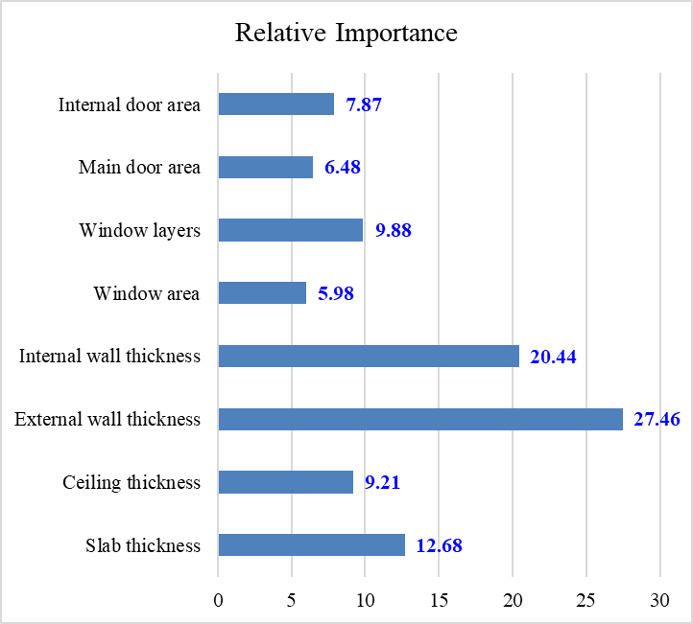 | 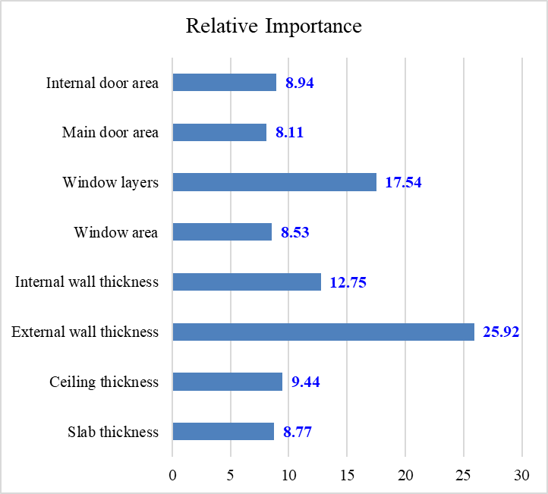
Model training 1 | Model training 2

Variable Perturbation method
Effect of different external wall thicknesses
X1 | X2 | X3 | X4 | X5 | X6 | X7 | X8 | Output
Slab thickness | Ceiling thickness | External wall thickness | Internal wall thickness | Window area | Window layers | Main door area | Slab thickness | Energy requirement | Changing (%)
200 | 11 | 100 | 100 | 1.8 | 2 | 3.96 | 1.26 | 26,028.80 | 0.00
200 | 11 | 150 | 100 | 1.8 | 2 | 3.96 | 1.26 | 25,448.75 | -2.23
200 | 11 | 200 | 100 | 1.8 | 2 | 3.96 | 1.26 | 24,928.20 | -4.23
200 | 11 | 250 | 100 | 1.8 | 2 | 3.96 | 1.26 | 24,441.04 | -6.10

Effect of different internal wall thicknesses
X1 | X2 | X3 | X4 | X5 | X6 | X7 | X8 | Output
Slab thickness | Ceiling thickness | External wall thickness | Internal wall thickness | Window area | Window layers | Main door area | Slab thickness | Energy requirement | Changing (%)
200 | 11 | 200 | 100 | 1.8 | 2 | 3.96 | 1.26 | 23695.153 | 0.00
200 | 11 | 200 | 150 | 1.8 | 2 | 3.96 | 1.26 | 23189.818 | -2.13
200 | 11 | 200 | 200 | 1.8 | 2 | 3.96 | 1.26 | 22741.115 | -4.03
200 | 11 | 200 | 250 | 1.8 | 2 | 3.96 | 1.26 | 22308.756 | -5.85

Effect of different window areas
X1 | X2 | X3 | X4 | X5 | X6 | X7 | X8 | Output
Slab thickness | Ceiling thickness | External wall thickness | Internal wall thickness | Window area | Window layers | Main door area | Slab thickness | Energy requirement | Changing (%)
200 | 11 | 200 | 100 | 1.2 | 2 | 3.96 | 1.26 | 23317.203 | 0.00
200 | 11 | 200 | 100 | 1.5 | 2 | 3.96 | 1.26 | 23508.772 | 0.82
200 | 11 | 200 | 100 | 1.8 | 2 | 3.96 | 1.26 | 23695.153 | 1.62
200 | 11 | 200 | 100 | 2.1 | 2 | 3.96 | 1.26 | 23876.823 | 2.40

Effect of different number of window layers
X1 | X2 | X3 | X4 | X5 | X6 | X7 | X8 | Output
Slab thickness | Ceiling thickness | External wall thickness | Internal wall thickness | Window area | Window layers | Main door area | Secondary door area | Energy requirement | Changing (%)
200 | 11 | 200 | 100 | 1.8 | 1 | 3.96 | 1.26 | 23850.320 | 0.00
200 | 11 | 200 | 100 | 1.8 | 2 | 3.96 | 1.26 | 23695.153 | -0.65
200 | 11 | 200 | 100 | 1.8 | 3 | 3.96 | 1.26 | 23642.009 | -0.87

OPTIMIZATION FOR ENERGY PROBLEM

X.1. Problem statement
Energy optimization
Energy optimization means using – and not using – energy in the built environment to maximize benefits for the climate and for people. (Energy Foundation.org)
Benefits of Energy optimization:
- Environmental: Increased efficiency can lower greenhouse gas (GHG) emissions and other pollutants, as well as decrease water use.
- Economic: Improving energy use can lower individual utility bills, create jobs, and help stabilize electricity prices and volatility.
- Utility System Benefits: Energy optimization can provide long-term benefits by lowering overall electricity demand, thus reducing the need to invest in new electricity generation and transmission infrastructure.
- Risk Management: Energy optimization also helps diversify utility resource portfolios and can be a hedge against uncertainty associated with fluctuating fuel prices.

Criteria for optimizing a given energy system
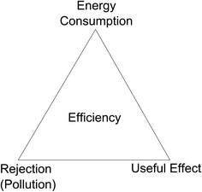
The triangle of basic optimization criteria
Today, multicriteria analysis: the simultaneous consideration of energy, environment, and economy
Designed variables
 | External wall thickness | Internal wall thickness | Window area
 | x3 | x4 | x5
lower bound | 100 | 100 | 1.2
upper bound | 400 | 300 | 2.2

Fixed variables
 | Slab thickness | Ceiling thickness | Window layers | Main door area | Secondary door area
 | x1 | x2 | x6 | x7 | x8
values | 150 | 11 | 2 | 3.96 | 1.68

Architectural constraints
Wall thickness
$$\frac{1}{16}H_{story}≤x_{3}$$
$$\frac{1}{32}H_{story}≤x_{4}$$
Total wall thickness by area
$$\frac{{x_{3}L_{3}+x}_{4}L_{4}}{A_{floor}}≤0.15$$
Total window areas
$$\frac{\sum{x_{5}}}{A_{floor}}≤\frac{1}{4}$$

X.2. Solution
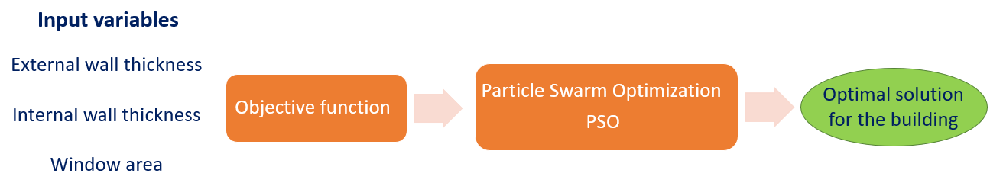
Objective function
- Estimating energy requirement by trained Neural Network model:
$$Φ\left(\text{x}\right)=\text{NN}\left(\text{x}\right)$$

- Applying the constraints using penalty approach:
$$P\left(\text{x}\right)=r\left\{{max\left(0,\frac{1}{16}\frac{H_{story}}{x_{3}}-1\right)}^{2}+{max\left(0,\frac{1}{32}\frac{H_{story}}{x_{4}}-1\right)}^{2}+{max\left(0,\frac{{x_{3}L_{3}+x}_{4}L_{4}}{A_{floor}}-0.15\right)}^{2}+{max\left(0, \frac{\sum{x_{5}}}{A_{floor}}-\frac{1}{4}\right)}^{2}\right\}$$
where:
$r={10}^{6}$, $H_{story}=3600 (mm)$, $L_{3}=66950 (mm)$, $L_{4}=47950 (mm)$, and $A_{floor}=140.53×{10}^{6}({mm}^{2})$
- Objective function (to be minimized):
$$F\left(\text{x}\right)=Φ\left(\text{x}\right)+ P\left(\text{x}\right)$$
$$x=\left\{150, 11, x_{3},x_{4}, x_{5}, 2, 3.96, 1.68\right\}$$

Constriction Particle Swarm Optimization Algorithm
In this study, the Constriction particle swarm optimization algorithm is employed to solve the optimization problem described in the previous section. The position updating of a particle is presented as follows:
$$\left\{\begin{aligned}v_{i,t+1}^{d}=χ\left(v_{i,t}^{d}+ϕ_{1}×rand×\left(p_{i,t}^{d}-x_{i,t}^{d}\right)+ϕ_{2}×rand×\left(p_{g,t}^{d}-x_{i,t}^{d}\right)\right) \\ x_{i,t+1}^{d}=x_{i,t}^{d}+v_{i,t+1}^{d}\end{aligned}\right.$$where$$χ=\frac{2}{ϕ-2+\sqrt{ϕ^{2}-1ϕ}} , ϕ=ϕ_{1}{+ϕ}_{2}>4 \\ ϕ_{1}{=ϕ}_{2}=2.05$$
Results of the optimization problem
The algorithm is initialized with 80 particles and is run with maximum of 200 iterations. The results of the optimization are summarized as follows:
$${\text{x}}_{optimal}$$ | [150, 11, 291.5, 112.4, 1.2, 2, 3.96, 1.68] ^{(run 1)}  [150, 11, 291.5, 112.4, 1.2, 2, 3.96, 1.68] ^{(run 2)}  [150, 11, 291.6, 112.4, 1.2, 2, 3.96, 1.68] ^{(run 3)}
$$F\left({\text{x}}_{optimal}\right)$$ | 21368.210 ^{(run 1)}  21368.213 ^{(run 2)}  21368.213 ^{(run 3)}
$$Φ\left({\text{x}}_{optimal}\right)=\text{NN}\left({\text{x}}_{optimal}\right)$$ | 20626.000 ^{(run 1)}  20626.512 ^{(run 2)}  20624.574 ^{(run 3)}
$$P\left({\text{x}}_{optimal}\right)$$ | 742.210 ^{(run 1)}  741.701 ^{(run 2)}  743.639 ^{(run 3)}
$\left\{p_{i}\left({\text{x}}_{optimal}\right)\right\}$ * | [0.00, 2.42$×$10⁻⁷, 7.42$×$10⁻⁴, 0.00] ^{(run 1)}  [0.00, 2.66$×$10⁻⁷, 7.41$×$10⁻⁴, 0.00] ^{(run 2)}  [0.00, 2.63$×$10⁻⁷, 7.43$×$10⁻⁴, 0.00] ^{(run 3)}
*$\left\{p_{i}\right\}=\left\{{max\left(0,\frac{1}{16}\frac{H_{story}}{x_{3}}-1\right)}^{2}, {max\left(0,\frac{1}{32}\frac{H_{story}}{x_{4}}-1\right)}^{2}, {max\left(0,\frac{{x_{3}L_{3}+x}_{4}L_{4}}{A_{floor}}-0.15\right)}^{2}, {max\left(0, \frac{\sum{x_{5}}}{A_{floor}}-\frac{1}{4}\right)}^{2}\right\}$
The global best value of the objective function according to the number of iterations:
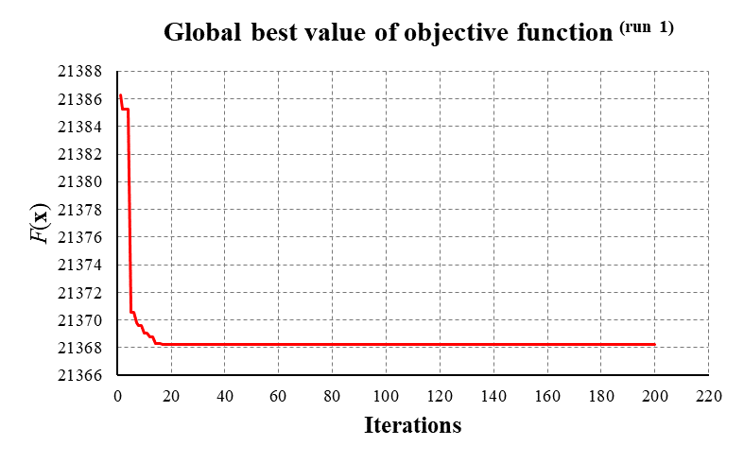
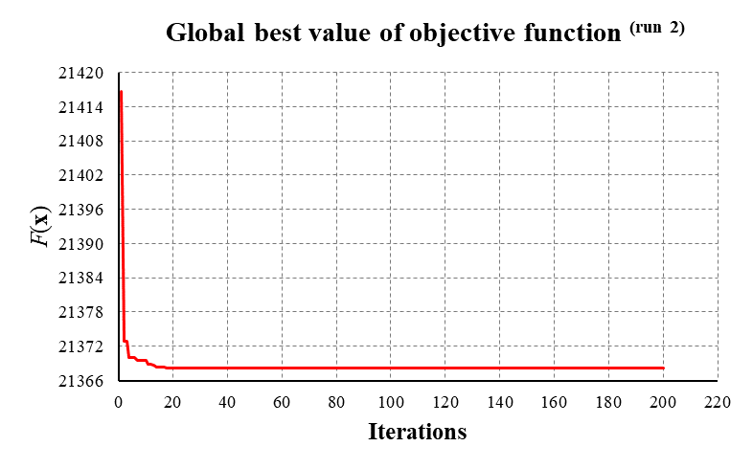
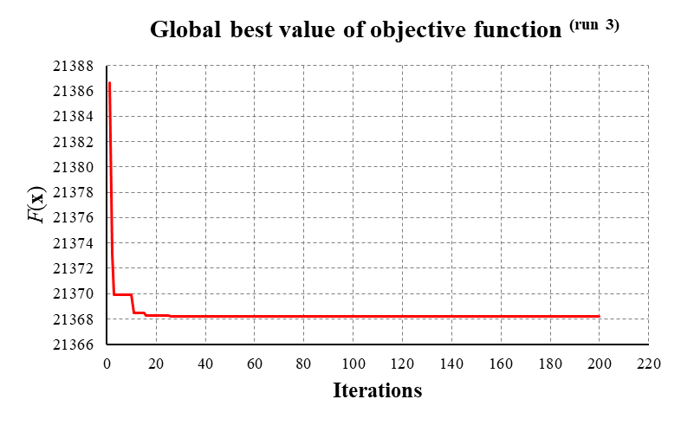

CONCLUSION AND FUTURE RESEARCH DIRECTION

XI.1. Conclusions
Under the supervision of Professor Magd Abdel Wahab - ICP coordinator at Ghent University, we have carried out a study with the objective of optimizing energy consumption for buildings, specifically residential building, in the Mekong Delta region, Vietnam.
For two months within the framework of this training program, this study was carried out with the objective of developing a feasible procedure for solving the problem as the commencement of the general project, while the number of samples generated, and the number of input variables considered were kept simple due to the limitations of time and computational facilities. After this program, a procedure for solving the posed problem of “Optimization of energy use/reduce energy usage in the buildings in Vietnam using Machine Learning” was successfully proposed, in which the main tasks performed include:
a. Locating the building.
b. Collecting regional climatic data at the study site.
c. Identifying a building for investigating.
d. Building energy model in Termus-Plus software.
e. Generating energy-related data from the simulation of Termus-Plus software.
f. Developing ML model for estimating the energy performance of the building based on the generated data.
g. Utilizing the ML model for optimizing the building in terms of reducing the energy requirements of the building.
Some conclusions which could be pointed out from the numerical results are listed as follows:
+ The level of energy consumption is most affected by the covering structure including wall, window, ceiling.
+ With surveyed variables being the geometry of structural materials, the relationship between input and output variables is almost linear.
+ The energy requirement is strongly affected by the change of environmental temperature. How the indoor temperature setpoints are managed also considerably influences the energy requirement.

XI.2. Achievements from the training program
- Termus-Plus software usability: after two months of training, we were able to use TerMus-Plus software to build an energy model for the building. This is BIM modeling software for dynamic energy simulation and analysis with EnergyPlus™. This software integrates the power of the high-performance EnergyPlus™ solver and the simplicity of BIM/3D modeling methods. With proficiency in the software, we can easily calculate energy efficiency and consumption for projects.
- Setting the sequence of modeling steps and calculate an energy optimization model: from building a 3D model with BIM object library and automatic thermal bridge calculation tool, after defining technical conditions and thermal data parameters by geographical area, an energy simulation and analysis can be performed, thereby calculating energy optimization for the building. With a clear and logical sequence like this, anyone who is just starting to learn about energy modeling can understand and easily follow.
- Gaining knowledge about energy saving in buildings: through building energy models, we get an overview of thermal behavior in the building, actual energy consumption and the main factors that affect the consumption, energy efficiency of different materials, usage profiles, time schedules, area and room loads, etc. Accurately and quickly into each factor, evaluate the choices made and compare them with alternatives.
- Raising awareness of climate change: the Termus plus model is a dynamic model, with each change of input data which could be climate data, the level of equipment uses in the buildings, architectural and structural design parameters, etc. energy requirements and CO2 emissions are all affected. These will affect the quality of the living environment of humans and contribute to climate change. When these effects are clearly realized, we shall make adjustments, changes in construction design, use of energy in order to reduce energy requirements and greenhouse gas emissions.

XI.3. Recommendations for follow-up research study
- In relating to the Termus-Plus software
- Develop interactive methods between programming language (matlab, python, so on…) and TerMus-Plus software to generate data automatically, serving the training process of ML model and surveying the influence of variables.
- Build a diverse and rich library of BIM models in terms of object and material types. This will facilitate users when building geometric models as well as setting up energy calculations.
- Improve the software to be able to effectively represent architectural objects: e.g., stairs, mezzanines, roofs, etc. Representing correctly of objects will make energy calculations more accurate.
- In relating to the VLIR-OUS project
  - Support for research activities on new materials with good insulation as well as finding clean energy sources.
  - Organize workshops to raise awareness about climate change.
  - Cooperate with industrial sectors and government for a comprehensive project to solve climate problems, in which researchers and scientists can approach the environmental database and related documents for the research.
  - Associate with the software development company to provide users complete documentation of the software in terms of fundamentals, theories, and tutorials.
- Future research directions
- Improving the database both in terms of the size and number of surveyed variables.
- In the energy calculations carried out by TerMus-Plus software, basically an energy object encompasses geometric parameters and thermal parameters which are inter-interactable. For example, if the thickness of the material layer increases, the thermal conductivity consequently decreases. For another example, if the objects are constructed with the same thicknesses but from different material types, the thermal conductivities of them are accordingly different. Therefore, these parameters should be both included in the input variables, or in general, this point should be considered for investigations of future studies.
- Considering various aspects for energy optimization, such as cost, architectural constraints, human needs, policies of economy and social, and other aspects relating to construction.
- Investigating more input variables to increase the accuracy of simulation results.
- Currently the output variable is only an energy requirement, future research should implement the remaining outputs.
- Using machine learning to compute outputs in bulk.
- Developing new machine learning models for predicting the energy performance of the buildings in time-dependent consideration.

-- End --

Clerc, M., & Kennedy, J. (2002). The particle swarm-explosion, stability, and convergence in a multidimensional complex space. IEEE transactions on Evolutionary Computation, 6(1), 58-73.

